**EXPLORATORY ATTENTIONAL RESOURCE ALLOCATION IN A PROBABILISTIC FORAGING**

**PARADIGM IN THE MONGOLIAN GERBIL**

Thesis submitted to the Faculty of Natural Sciences of Otto-von-Guericke

University Magdeburg for the degree of

**Master of Science (Integrative Neuroscience)**

*on*

25th May 2021

*by*

**Parthiban Saravanakumar**

Matriculation No: **223956**

**ACKNOWLEDGEMENTS**

First of all, I thank my supervisor PD Dr. Max Happel, for giving me an opportunity to work in his Cortxplorers group and correctly guiding me right from the start of the project. I am thankful to Prof. Dr. Frank Ohl, PD Dr. Maike Vollmer, and the master student Sabina Nowakowska who helped me a lot in

planning and building the setup for this project.

Next, I wish to express my gratitude to the current PhD students in my working group, Katrina Deane and Ebru Acun for their constant moral support. A special thanks to Dr. Marina Zempeltzi for teaching me the basics of electrophysiology. Many thanks to Dr. Michael Brunk, Jing Ma, Alina, and Sumeyra who were also part of my journey in the Cortxplorers group. I would also like to thank all the

technical assistants of the SPL group for their valuable support.

I want to thank all my friends in Magdeburg and also in other parts of Germany who were always constantly supporting me at my back. I wish to avail myself of this opportunity to thank my beloved parents and my brother for their continuous support. At last, I want to thank the almighty for pouring his/her blessings on me to

finish the project successfully.

**Parthiban Saravanakumar**

**ABSTRACT**

Neuronal resource allocation is essential for any cognitive function of the brain.

Human and monkey studies have revealed that the anterior prefrontal cortex plays

a crucial role in exploratory resource allocation processes. In rodents also, the

prefrontal cortex region has been studied to assess exploration/exploitation trade-

offs using various behavioral paradigms. However, in the context of such variable

switches of exploratory resource allocation, the role of the frontal cortex is still

under discussion. In the current study, a probabilistic foraging paradigm was

developed using the Mongolian gerbil (*Meriones unguiculatus*) as the animal

model abetted by food restriction. A critical parameter for the investigation of

exploration/exploitation trade-offs is the so-called economic switching costs. In

order to manipulate these, three different foraging setups were used with a

difference in their travel distance between two foraging spouts where the animal

was able to approach consecutively. With each new approach, the reward

probability was reduced exponentially in order to force a trade-off to explore

another food source. Firstly, a food restriction paradigm was developed that

evoked sufficient motivational search behavior while the animals still exhibited

stable physical conditions measured by dense body weight monitoring. A

quantitative analysis of different foraging parameters was used to characterize the

**i**

foraging behavior in early and established (performing) phases. By applying

various statistical analyses (Wilcoxon rank-sum test, two-way ANOVA), it was

found that the change in travel distance between the foraging spouts has a less

influence on the behavior of the animals. The findings of this study pave the way

for investigating the neuronal resources in the frontal cortex during exploratory

resource allocation in the food-searching gerbil.

**Keywords:** aPFC, Mongolian gerbils, food restrictions, foraging task, travel

distance, Wilcoxon rank-sum test, two-way ANOVA

**ii**

**TABLE OF CONTENTS**

**ABSTRACT**

**i**

**LIST OF TABLES**

**vii**

**LIST OF FIGURES**

**viii**

**INDEX OF NOTATION**

**xi**

**1**

**INTRODUCTION**

**1**

1.1. Resource allocation

1

1.2. Exploration/exploitation

1

1.3. Role of anterior prefrontal cortex in exploration-exploitation trade-off

2

1.4. Exploratory resource allocation in rodents

4

1.5. Approach for investigating the exploration/ exploitation trade-off

5

1.5.1. Probabilistic foraging task

5

1.6. Aim and objectives of the study

7

**2**

**MATERIALS AND METHODS**

**9**

2.1. Animal subjects

9

2.2. Food restriction

9

2.3. Foraging setup

10

**iii**

2.3.1. Foraging box

10

2.3.2. Other devices and software

12

2.4. Probabilistic foraging paradigm

13

2.5. Data analysis

15

2.5.1. Animals‘ weight and food intake

15

2.5.2. Session-wise analysis

15

2.5.2.1. Time spent for nose poking in the foraging spout

16

2.5.2.2. Total number of nose-pokes

16

2.5.2.3. Rate of nose poking

16

2.5.2.4. Inter poke intervals between two successive nose-pokes

16

2.5.2.5. Time taken to travel from one spout to another spout

17

2.5.2.6. Statistical methods

17

2.5.3. Trial-wise analysis

17

2.5.3.1. Total number of nose-pokes

18

2.5.3.2. Total number of unrewarded nose-pokes

18

2.5.3.3. Number of consecutive unrewarded nose-pokes before spout leaving

18

2.5.3.4. Total number of rewards

18

2.5.3.5. Poke number of the first reward

19

**iv**

2.5.3.6. Statistical methods

19

**3**

**RESULTS**

**20**

3.1. Effect of food intake on animals‘ bodyweight in foraging sessions with different foraging setups

20

3.1.1. Short box

20

3.1.2. Long box

20

3.2. Session-wise analysis

22

3.2.1. Time spent by the animals for nose poking in the foraging spout

23

3.2.2. Number of nose-pokes made by the animals in the foraging spout

24

3.2.3. Rate of nose poking in the foraging spout by the animals

25

3.2.4. Inter poke intervals between the successive nose-pokes in the foraging spout

27

3.2.5. Time taken by the animals to travel from one spout to another spout

29

3.3. Trial-wise analysis

30

3.3.1. Number of nose-pokes made by the animals in the foraging spout

31

3.3.2. Number of unrewarded nose-pokes made by the animals at the foraging spout

33

3.3.3. Number of consecutive unrewarded nose-pokes made by the animals before leaving the spout

35

**v**

3.3.4. Number of rewards obtained by the animals

37

3.3.5. Poke number of the first reward obtained by the animals

38

**4**

**DISCUSSION**

**40**

4.1. Feeding of the animals

41

4.2. Performance of the animals in different foraging setups

42

4.3. Performance of the animals in different trial types of the probabilistic foraging task

43

4.4. Evaluation of the probabilistic foraging paradigm in food- restricted Mongolian gerbils

45

**5**

**CONCLUSION**

**47**

5.1. Perspectives

47

**6**

**APPENDIX**

**49**

A. Supplementary figures

49

A.1. Session-wise analysis

49

A.2. Trial-wise analysis

59

B. Supplementary table

64

C. Video recordings of foraging experiments

64

**7**

**BIBLIOGRAPHY**

**65**

**DECLARATION**

**69**

**vi**

**LIST OF TABLES**

**S16**

Total number of trials in different trial types (starting probabilities) in performing phase sessions of different foraging setups

64

**vii**

**LIST OF FIGURES**

**1.1**

Location of cytoarchitectonic BA 10 (shaded in red) surface rendered onto the orbital and medial surface of the human brain

2

Significantly increased activation in the regions of left (lFP) and right (rFP) frontopolar cortex on comparison of exploratory with exploitative trials

3

**1.2**

**1.3**

Caricature of a mouse performing the water-rewarded foraging task in the foraging platform with trigger and reward zone of at the ends

4

**1.4**

The probabilistic foraging task

6

**2.1**

Foraging setup (without walls) with spouts at the ends attached to food dispensers with a camera at the top

11

**2.2**

MatLab application showing an animal‘s performance during foraging task

12

**2.3**

Video recording during foraging task using OBS software

13

**2.4**

Exponential decay of reward probabilities for three different starting reward probabilities

14

**3.1**

Bodyweight of the animals and daily food intake during foraging sessions in different foraging setups

21

Duration of nose-poking at the foraging spout in performing phase sessions of different foraging setups

23

**3.2**

**3.3**

Number of nose-pokes in the foraging spout in performing phase sessions of different foraging setups

24

**3.4**

Rate of nose poking in the foraging spout in performing phase sessions of different foraging setups

26

**viii**

**3.5**

Inter poke interval between the successive nose-pokes in the foraging spout in performing phase sessions of different foraging setups

28

**3.6**

Difference between the inter poke intervals of rewarded and unrewarded preceding hit poke in performing phase sessions of different foraging setups

29

**3.7**

Time taken to travel between the foraging spouts in performing phase sessions of different foraging setups

30

**3.8**

Number of nose-pokes in the foraging spout indifferent to trial types of performing phase sessions of different foraging setups

32

**3.9**

Number of unrewarded nose-pokes at the foraging spout in different trial types of performing phase sessions of different foraging setups

34

**3.10**

Number of consecutive unrewarded nose-pokes before leaving the foraging spout in different trial types of performing phase sessions of different foraging setups

36

Number of rewards obtained in different trial types of performing phase sessions of different foraging setups

37

**3.11**

**3.12**

Poke number of the first reward in different trial types of performing phase sessions of different foraging setups

39

**5.1**

Perspectives

48

**S1**

Number of trials done by the animals in each session in three different foraging setups

49

**S2**

Time (in s) spent by the animals for nose poking in the foraging spout

50

**S3**

Total number of nose-pokes (both hit and error pokes) done by the animals

51

**S4**

Total number of hit pokes done by the animals

52

**ix**

**S5**

Poke rate (pokes/s) of the total number of nose-pokes (both hit and error pokes) done by the animals

53

**S6**

Poke rate (pokes/s) of hit pokes done by the animals

54

**S7**

Inter poke interval (in s) in which preceding hit poke was rewarded

55

Inter poke interval (in s) in which preceding hit poke was unrewarded

56

**S8**

**S9**

Difference between inter poke intervals (in s) of rewarded and unrewarded preceding hit poke

57

**S10**

Time (in s) taken by the animals to travel from one spout to another spout in the foraging setup

58

**S11**

Total number of rewards (food pellets) obtained by the animals in each trial

59

Number of nose-pokes done by the animals in each trial

60

**S12**

**S13**

Number of unrewarded nose-pokes done by the animals in each trial

61

**S14**

Number of consecutive unrewarded nose-pokes done by the animals before leaving the spout in each trial

62

**S15**

Poke number of first reward in each trial

63

**x**

**INDEX OF NOTATION**

**ANOVA**

Analysis of Variance

**aPFC**

anterior Prefrontal Cortex

**BA**

Brodmann Area

Baseline Bodyweight

**BBW**

Current Source Density

**CSD**

**fMRI**

Functional Magnetic Resonance Imaging

**FPC**

Frontopolar Cortex

**IPI**

Inter Poke Interval

**lFP**

left Frontopolar Cortex

Local Field Potentials

**LFP**

**mPFC**

medial Prefrontal Cortex

**MVT**

Marginal Value Theorem

**rFP**

right Frontopolar Cortex

Setups

**ST**

Trial Types

**TT**

**WCST**

Wisconsin Card Sorting Test

**xi**

**1. INTRODUCTION**

**1.1. RESOURCE ALLOCATION**

Performing a deterministic task relies on the coordination of different brain mechanisms involving various brain regions. The decisions made during the task require the allocation of scarce processing resources to the brain systems that involve task understanding, response planning, and action implementations. In the course of a task, a population of neurons was recruited in the brain system relevant to the task which fires in response to certain inputs. The metabolic resource- dependent (oxygen and glucose) neuron firing transmits the information to another neuron population via electrical impulses and chemical signals so that the choices were made during the task and signals sent to the motor system for executing the action (Alonso et al., 2013). The metabolic resources lineate with the neuronal resources, as only limited amounts of neuronal activity can be used at a time. In certain tasks, this metabolic resource limitation also means cognitive limitation. This study focuses on the cognitive resource of attention which can be distributed to focal or global aspects of the sensation and henceforth the exploration and

exploitation concepts were examined.

**1.2. EXPLORATION/EXPLOITATION**

The choice of deciding between exploration and exploitation in search of a reward is hard for any species in this world. At times, humans tend to shift away from actions with known outcomes (exploitation) and experiment with untried options (exploration) which could possibly increase their long-term success (Beharelle et al., 2015). The exploration/exploitation dilemma can be resolved by adopting

different exploratory strategies, and different theoretical frameworks that deliver

**1**

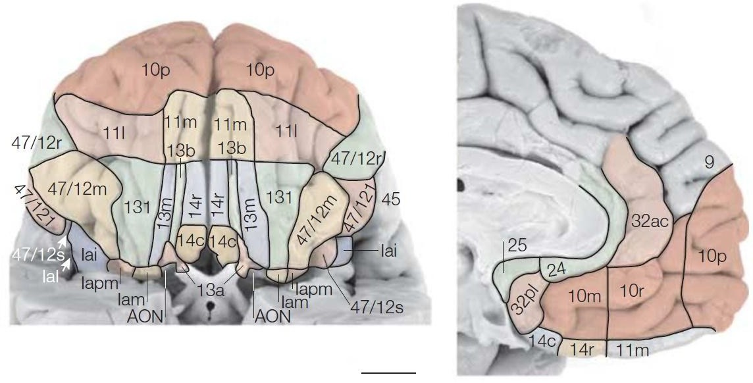

exploration driving factors. The explorations could be random processes in accordance with reinforcement learning theory while they were regarded as directed or intentional processes in optimal decision-making theories (Dezza et al.,

2017).

**1.3. ROLE OF ANTERIOR PREFRONTAL CORTEX IN EXPLORATION-**

**EXPLOITATION TRADE-OFF**

In humans, the Brodmann area (BA) 10 is mostly related to the anterior region of the prefrontal cortex covering a remarkably larger proportion of the cortex. The anterior prefrontal cortex (aPFC) could be involved in problem-solving, which implies more than one discrete cognitive process. This leads to speculation that the aPFC may play an important role in the coordination of processing and transfer of

information between numerous cognitive operations (Ramnani & Owen, 2004).

**(a)**

**(b)**

**Fig. 1.1. Location of cytoarchitectonic BA 10 (shaded in red) surface rendered onto the**

**(a) orbital and (b) medial surface of the human brain (From Ramnani & Owen, 2004)**

**2**

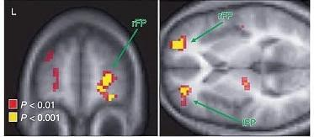

An fMRI study in human participants performing the four-armed bandit task that demands a choice among the four slot machines alongside the classification of trials as the dominant slot machine with the highest expected value (exploitative) or lowest expected value (exploratory), revealed that the anterior frontopolar cortex could be considered as the driving mechanism that facilitates the switching between the behavioral strategies of exploratory and exploitative approaches (Daw et al., 2006). A similar kind of bandit task in humans along with transcranial stimulation over the frontopolar cortex (FPC) showed that exploratory behavior was intensified by excitatory neuronal stimulation of the FPC but the reduction of such excitatory stimulation resulted in more exploitative choices (Beharelle et al.,

2015).

**Fig. 1.2. Significantly increased activation in the regions of left (lFP) and right (rFP) frontopolar cortex on comparison of exploratory with exploitative trials**

**(From Daw et al., 2006)**

The FPC-lesioned macaque monkeys displayed enhanced performance

by

exploiting the current task in Wisconsin Card Sorting Test (WCST) by possessing

a strong working memory for maintaining the information of the appropriate rule of the current task while facing many interruptions (other irrelevant samples and

**3**

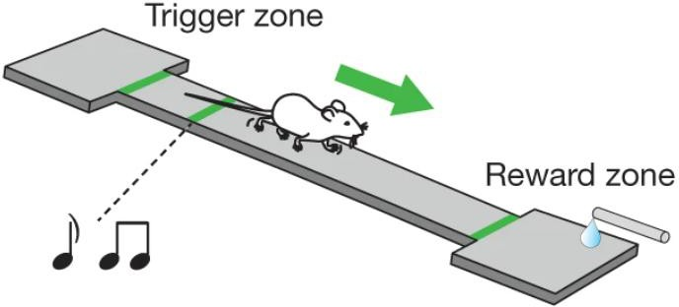

alternative rules). The FPC has a unique role in redistributing the executive control resources among potential goals existing in complex, changing situations

(Mansouri et al., 2015).

**1.4. EXPLORATORY RESOURCE ALLOCATION IN RODENTS**

Examination of the neural dynamics of the medial prefrontal cortex (mPFC) of a rat performing the tone-cued behavioral task of making choices between two

reward probabilities (high or low), exhibited a sudden, coordinated, and extensive

shift in neural population activity in the mPFC when

change in their environment (Karlsson et al., 2012).

the

animal

recognizes

a

**Fig. 1.3. Caricature of a mouse performing the water-rewarded foraging task in the foraging platform with trigger and reward zone of at the ends**

**(From Kvitsiani et al., 2013)**

Electrophysiological recordings from two classes of inhibitory interneurons (parvalbumin and somatostatin) in the mouse prefrontal cortex while executing the foraging task between the trigger and water-reward zones show that the responses

of these interneurons are accountable for the animal‘s foraging decisions i.e.

**4**

approach for staying and leaving the reward zone (Kvitsiani et al., 2013). Specifically, the somatostatin neurons had a selective response for the exploratory behavior, i.e. when the animal approached the reward zone, and the parvalbumin

neurons responded at the reward leaving approach.

**1.5.**

**APPROACH**

**FOR**

**INVESTIGATING**

**THE**

**EXPLORATION/**

**EXPLOITATION TRADE-OFF**

Animals have the ability to show flexible behavior based on their previous experiences in that environment but the mechanism of the information encoded in animal‘s brains pertaining to their behavior remains unclear. Different behavioral tasks have been given to the animals for studying their frontal cortex activity during active exploration of the environment. Nevertheless, the role of the frontal cortex in exploration behavior is still debatable (Karlsson et al., 2012). This raises the need for a well-designed behavioral paradigm to study the exploration/

exploitation trade-off in animals.

**1.5.1. PROBABILISTIC FORAGING TASK**

In the present study, the well-known animal model, Mongolian gerbil (*Meriones unguiculatus*), was used as their cortex is well described in systems neuroscience. Also, studies have been performed with them to show the role of the frontal cortex during decision making (Stark et al., 2004) which requires considerable space for building the behavioral setup. Furthermore, techniques for chronic recordings and optogenetic manipulation were also developed on these animals (Brunk et al., 2019; Zempeltzi et al., 2020). Here, the animals were food-restricted for carrying

out the probabilistic foraging task but the water was supplied ad libitum.

**5**

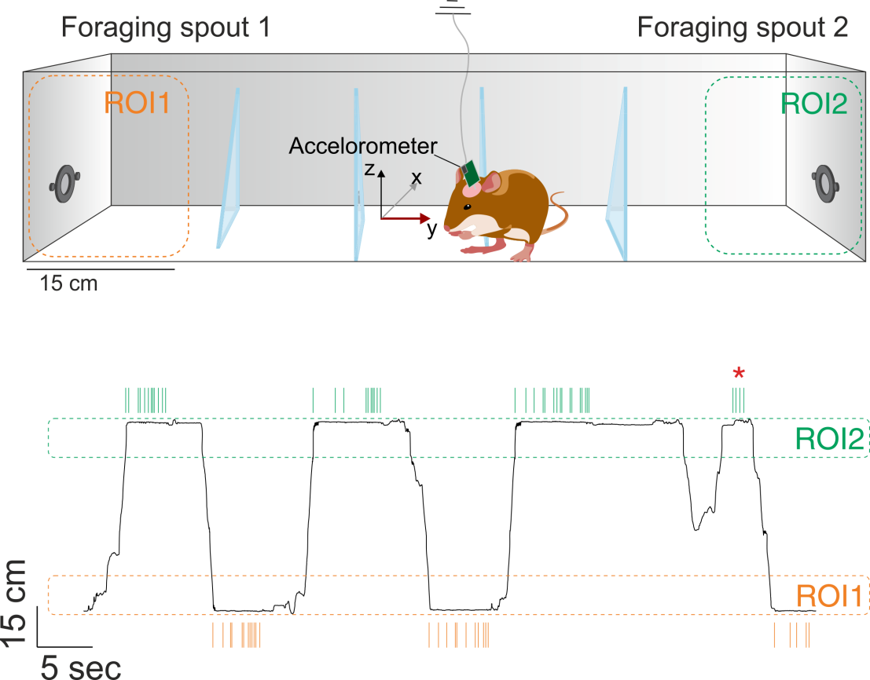

**(a)**

**(b)**

**Fig. 1.4. The probabilistic foraging task. (a) Schematic representation of the foraging setup with foraging spouts at the ends of the setup; (b) One-dimensional location of an example animal along the axis of the box plotted as a function of time (green & orange ticks: nose-**

**pokes, red asterisk: error trial) (From Lottem et al., 2018)**

For studying the exploration/exploitation trade-off in Mongolian gerbils, the probabilistic foraging setup adapted from Lottem et al., 2018 was built. The random probability schedule for the rewards in this foraging task allows the animals to forage between the foraging spouts, yielding many trials that account

for both exploration and exploitation strategies.

As the advent of rewards was not cued to the animals during the task, the foraging approach was based on the actual rewards received in the trial so that a fixed, reward-independent behavioral strategy would be avoided. Moreover, by adopting the probabilistic foraging paradigm, many foraging parameters (Fantino & Abarca,

1985) can be studied easily.

**6**

In the current study, the probabilistic foraging task was also helpful in investigating the impact of the travel distance between the foraging spouts with the support of three different foraging arenas with various travel distances (short box

and long box foraging setups).

**1.6. AIM AND OBJECTIVES OF THE STUDY**

The aim of this study was to establish a probabilistic foraging paradigm in food- restricted Mongolian gerbils for investigating the exploration/exploitation trade- offs. This Master‘s Thesis mainly focuses on developing a probabilistic foraging paradigm (Lottem et al., 2018) in food-restricted Mongolian gerbils which is a new

development of a procedure in this animal model that has never been tested before.

The discrete objectives of the current study were:

1.

Establishing a suitable food restriction regime in the Mongolian gerbil to allow the titration of sufficient motivational drive and keep the animals in a healthy physical state. Hence, the daily food intake and bodyweight of the animals was closely monitored with respect to the behavioral performances of the animals.

Constructing the foraging setup in which probabilistic foraging paradigm would be used to examine the exploration and exploitation approaches of the animals. Then, distinct behavioral parameters of the probabilistic foraging task were analyzed to assess the performance of the animals in the foraging task. In the end, the best foraging parameter for identifying the performing phase of the animals would be enumerated.

Replication of the foraging setup with various travel distances between the

foraging spouts and using a statistical tool (Wilcoxon rank-sum test) to

2.

3.

**7**

inspect the impact of different travel distances in between the spouts of the foraging setup on animals‘ behavior in the probabilistic foraging task.

Comparing the performances of the animals in different trial types across

different forms of the foraging setups by applying various statistical analyses (Wilcoxon rank-sum test, 2-way ANOVA) to check whether the trial types

4.

influenced any change in

probabilistic foraging task.

the

foraging

behavior

of

the

animals

in

the

**8**

**2. MATERIALS AND METHODS**

In this study, a probabilistic foraging task was performed with food-restricted Mongolian gerbils (*Meriones unguiculatus*). The main purpose of this study was to develop a probabilistic foraging paradigm based on food restrictions for the animals which was adapted from the water restricted probabilistic foraging task

(cf. Lottem et al., 2018).

**2.1. ANIMAL SUBJECTS**

Experiments were carried out with adult male Mongolian gerbils (n=8, in-house breeding). The age of the animals was 3 to 4 months while performing foraging tasks in the short box. When the same eight animals were used in the foraging task with the long box, their age was 4 to 7 months. All animals were housed at a temperature of 25˚C and humidity 30 - 50% under a 12-hr dark/light non-inverted cycle. The conventional cages (Type IV) with raised wire lids were used, which allows nesting. Their cages were filled with hay, woodchips, and paper-based bedding. For the enrichment of their environment, tunnels were placed inside the

cage.

**2.2. FOOD RESTRICTION**

The animals had free access to water but were food restricted from three days before the start of the foraging task. The bodyweight of the animals was monitored daily from the day of food restriction. The average of bodyweights measured during the three days of food restriction before the start of the foraging task was called baseline bodyweight (BBW). The BBW of the animals was 70 - 80g before starting the foraging task in the short box, while the BBW was 80 - 95g in the case of the long box. To keep the animals' bodyweights above the critical level (85% of

**9**

BBW) during the foraging task period, food was supplemented inside the cage at least 2 hours after the end of the foraging task. The daily food intake of animals was maintained between 3 - 7g based on the performance of the animals in the

foraging task.

**2.3. FORAGING SETUP**

The foraging setup consisted of an arena/foraging box where the animal performed the task. There were two foraging spouts present on opposite sides of the box where the food was dispensed. Food dispensers were controlled by custom-built Arduino hardware, which was operated by an experimenter using a custom-written

Application program in MatLab.

**2.3.1. FORAGING BOX**

The foraging box was placed in an electrically shielded and sound-proof chamber. The framework of the box was made with wood while the walls of the foraging box were made up of cylindrical plastic bars placed 1cm apart from each other. The floor of the box was made up of plastic mesh; therefore underneath the floor, a large tray was placed to collect animals‘ excrement. The two spouts were placed on the ends of the box. Each spout was attached to a food dispenser (Campden Instruments Ltd., USA) placed outside the foraging box. On the sides of the spouts, an infrared emitter/sensor pair was located to measure the nose-pokes of the

animals.

The dimensions of the foraging box were 37cm x 26cm x 48cm (short box, **fig 2.1 (a)**) and 70cm x 31cm x 45cm (long box, **fig 2.1 (b)**). The distance between the spouts was 36cm (short box) and 67cm (long box). In the long foraging box, there

were provisions for placing walls in between the spouts. Three walls were placed

**10**

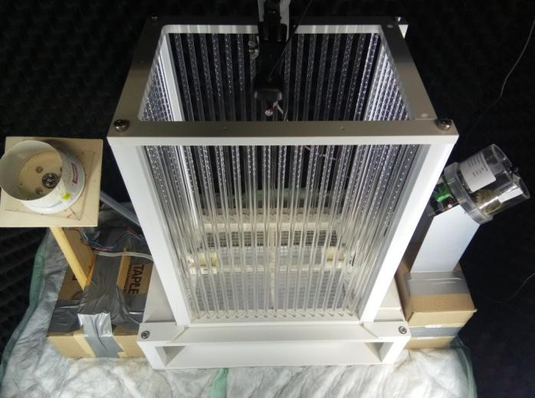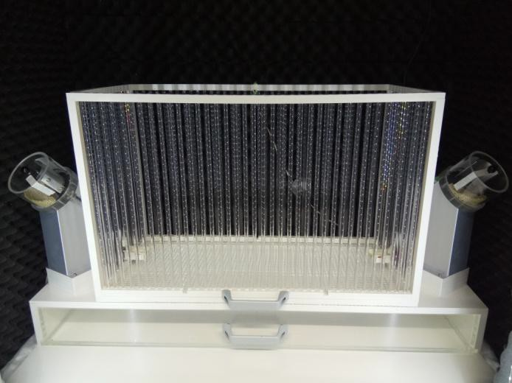

in which two were kept at a distance of 17.5cm from the ends of the box and one

was kept at the middle of the box.

**(a)**

**(b)**

**Fig. 2.1. Foraging setup (without walls) with spouts at the ends attached to food dispensers with a camera at the top. (a) Short box; (b) Long box**

**11**

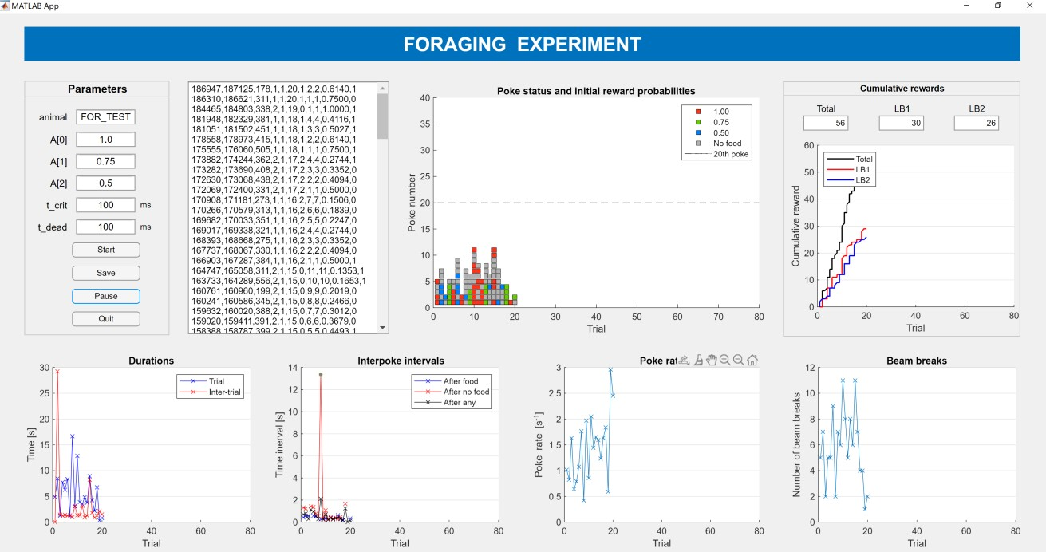

**2.3.2. OTHER DEVICES AND SOFTWARE**

The whole experimental session was recorded with a camera (Microsoft LifeCam HD-3000) placed above the foraging box. The camera was positioned in such a way that the field of view included the whole floor of the foraging box, spouts, and lower parts of the walls to properly monitor animal behavior during the experiment

(**fig 2.3**).

**Fig. 2.2. MatLab application showing an animal’s performance during foraging task**

A red LED light positioned below the camera for detecting hit pokes (see section **2.4**) was also covered during the video recordings. The light source was provided in the form of two vertical light panels attached on both sides of the chamber door

to aid the recordings.

The food dispensers were controlled by a custom-made microcontroller device which was commanded by a custom-written Arduino codenamed ―Foraging_02‖. The whole foraging setup was governed by a MatLab code ―Foraging_05_App‖. This MatLab code receives the input from the user and the Arduino commands

**12**

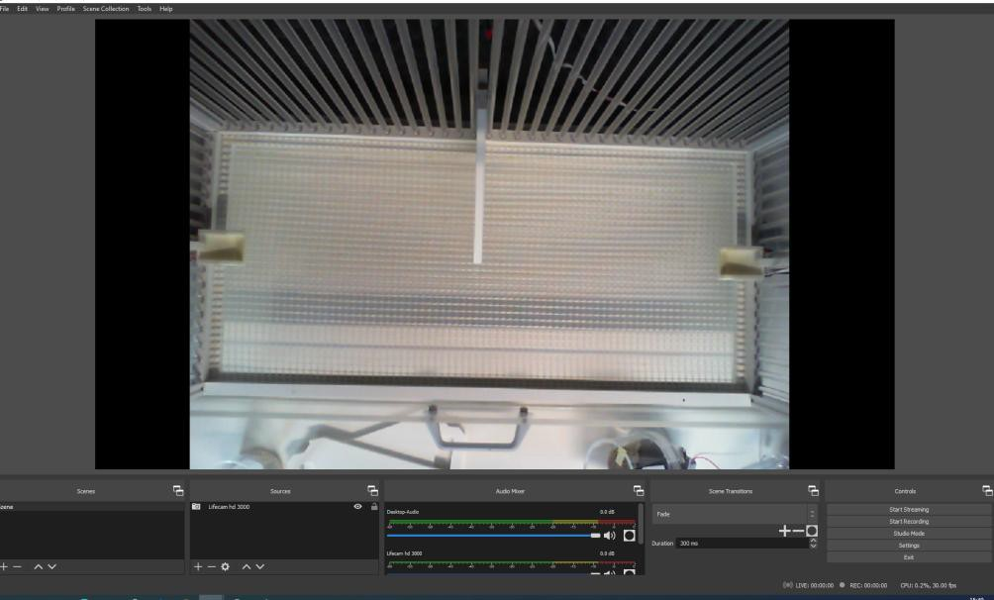

were passed through to obtain the information regarding each animal‘s behavior in

foraging task (**fig 2.2**). For video recording the

software was used.

whole foraging task, OBS 25.0.8

**Fig. 2.3. Video recording during foraging task using OBS software**

**2.4. PROBABILISTIC FORAGING PARADIGM**

The probabilistic foraging task (cf. Lottem et al., 2018) was carried out

without

any prior trainings or habituation in the foraging setup. Each animal was trained for one session per day. In each session, the animal could perform the foraging

behavior for a maximum of 30 minutes.

Each foraging session consisted of an ‗N‘ number of trials in accordance with the animal‘s behavior. Every trial contained a sequence of nose-pokes in one of the two foraging spouts. Error pokes were the ones that lasted for less than 100ms while the pokes that lasted for at least 100ms were called hit pokes. The error pokes were unrewarded and the hit pokes were either rewarded with 20mg of

commercially available food pellet or unrewarded based on the reward probability

**13**

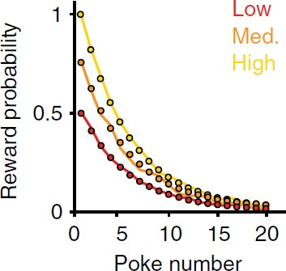

and reward outcome of that poke (for details see below). The reward probabilities decreased after each hit poke, forcing the animal to alternate between the spouts

during the foraging session.

Three different reward probabilities were used, which decreases exponentially with

each increasing hit poke number according to the equation,

P (on = 1|ti) = Ai e-(n-1)/5

where ti is the ith trial type (i = 1,2,3) corresponding to different exponential scaling factors of A1 = 1.0, A2 = 0.75, A3 = 0.75 (**fig 2.4**). ‗n‘ marks the hit poke number within a trial, and on is the outcome of the poke (1 for reward and 0 for no reward). Trial types (exponential scaling factors) were randomly interleaved and trial type identity was not cued to the gerbils. Reward probability was set to zero during error pokes. To obtain more trials from the animals and to maintain the motivation of the animals for a longer period, the reward probability was set to zero after the 20th nose-poke of a trial. A dead time of 100ms was set to pause the

session whenever the rewarding hit poke had occurred.

nth

**Fig. 2.4. Exponential decay of reward probabilities for three different starting reward probabilities (From Lottem et al., 2018)**

**14**

Once the animal had learned the foraging task well, they might have done other activities like biting the bars on the walls of the foraging box and jumping along the sides of the foraging box. In such a case, the foraging task was suspended and

the animal was taken out of the foraging box.

The foraging paradigm was accomplished in three different foraging setups such

as,

•

•

•

without any walls in between the spouts - short box

without any walls in between the spouts - long box with three walls in between the spouts - long box

**2.5. DATA ANALYSIS**

All data analysis was executed using custom-written codes in MatLab Software.

**2.5.1. ANIMALS’ WEIGHT AND FOOD INTAKE**

The baseline bodyweight measurement of each animal (n=8) was used to calculate the respective animal‘s weight in percentage for each foraging session. Then, the average percentage of animals‘ weights was calculated for each session. Likewise, the averages of the amount of food pellets eaten in the foraging task, quantity of food ingested inside the cage, and total food consumed for each foraging session

were calculated.

**2.5.2. SESSION-WISE ANALYSIS**

In session-wise analysis, five foraging parameters were analyzed as follows:

**15**

**2.5.2.1. TIME SPENT FOR NOSE POKING IN THE FORAGING SPOUT**

In each trial, the food-restricted animals will stay near one of the foraging spouts and nose-poke to obtain the food pellet as their reward. The time taken by the

animals for the nose poking in the spouts was calculated as:

Duration of nose-pokes (in s) = Time of last nose-poke - Time of first nose-poke

(within the same trial)

**2.5.2.2. TOTAL NUMBER OF NOSE-POKES**

Within a trial, the animals can nose-poke to their maximum extent but no reward

20th

will be given after its

hit poke. Therefore, the animals exploit the current

foraging spout by nose-poking a few times and move to the opposite spout. The

nose-pokes consist of both the hit pokes and the error pokes.

**2.5.2.3. RATE OF NOSE POKING**

The nose-pokes by the animals in the foraging spout were done at a particular rate

which was evaluated as:

Rate of nose poking (pokes/s) = Number of nose-pokes (within the same trial)

Duration of nose-pokes (s)

**2.5.2.4. INTER POKE INTERVALS BETWEEN TWO SUCCESSIVE NOSE-**

**POKES**

Inter poke intervals (IPI) were the duration between two successive nose-pokes in

which the preceding nose-poke was a rewarded or unrewarded hit poke.

Inter poke interval (in s) = Time of nth nose-poke - Time of (n-1)th hit poke

where, nth nose-poke could be a hit or error poke

(n-1)th nose-poke would have been rewarded or unrewarded

**16**

**2.5.2.5. TIME TAKEN TO TRAVEL FROM ONE SPOUT TO ANOTHER**

**SPOUT**

Travel time was the time taken by the animals for making the movement between

the foraging spouts. It was calculated as,

Travel time (in s) = Time of the first poke in the - Time of the last poke in the

current trial

preceding trial

**2.5.2.6. STATISTICAL METHODS**

As the data inside each session were not normally distributed, the median was

taken as the median was

medians of

best measure of each foraging parameter. For each parameter, the evaluated for each session of each animal. Then, the median of

all animals across each foraging session was visualized using

conventional box plots.

A decision criterion (see Results section **3.2**) was assigned in the foraging parameter of travel time to distinguish between animals‘ non-performing phases and performing phases. The sessions that fulfill the decision criterion were called performing phase sessions of the animals. Likewise, the performing phase sessions were noted down for each foraging setup. The median of medians of each of five parameters in the performing phase sessions was compared across the setups and

their significance levels were enumerated using Wilcoxon rank-sum test.

**2.5.3. TRIAL-WISE ANALYSIS**

In this part of the analysis, five different trial-based parameters were analyzed as

given below:

**17**

**2.5.3.1. TOTAL NUMBER OF NOSE-POKES**

The animals were trained to nose-poke in the foraging spout to obtain their rewards. Depending upon the duration of the nose-pokes, they were split into two

types as hit pokes and error pokes.

**2.5.3.2. TOTAL NUMBER OF UNREWARDED NOSE-POKES**

In every trial, the error pokes in the foraging spout which lasts for less than 100ms was unrewarded while the hit pokes lasting for at least 100ms were either unrewarded or rewarded with a food pellet based on the reward probability and reward outcome of that particular hit poke. Therefore, there could be more

unrewarded nose-pokes than rewarded nose-pokes in each foraging trial.

**2.5.3.3. NUMBER OF CONSECUTIVE UNREWARDED NOSE-POKES**

**BEFORE SPOUT LEAVING**

The animals exploited the foraging spout by nose poking and consumed the food pellets obtained as rewards. When the animals sensed that the rewards had depleted in the current foraging spout, they traveled to another foraging spout located on the opposite side of the setup. Hence, before leaving the current spout, the animals

tended to do a few unrewarded nose-pokes consecutively.

**2.5.3.4. TOTAL NUMBER OF REWARDS**

The hit pokes in the foraging spout with the reward outcome of 1 were always

rewarded with a 20mg food pellet. This could be measured as the number of rewards or rewarded hit pokes in each trial.

**18**

**2.5.3.5. POKE NUMBER OF THE FIRST REWARD**

In all of the foraging setups, the trial type with the starting probability of A=1 was always rewarded for its first hit poke. But for the other two trial types, the first

reward was obtained based on the reward outcome of that particular nose-poke.

**2.5.3.6. STATISTICAL METHODS**

At first, the individual trials done by the animals in the performing phase sessions

were listed down for each foraging setup. The medians of each parameter were

compared compared

rank-sum

across different setups for each starting reward probability and also across different starting reward probabilities for each setup. Wilcoxon

test was carried out to inspect the level of significance difference

between the medians for each parameter. As the number of hypotheses tested here was large (m=18), the statistical test was conducted for Bonferroni corrected significance values (α/m). For the trial-wise parameters, two-way ANOVA (analysis of variance) was also carried out to assess the main effects of each independent variable (setups (ST) and trial types (TT)) and the interaction between

them.

**19**

**3. RESULTS**

The number of sessions varied between the short box and the long box for few animals. Hence, for our analysis, the first 15 sessions in the short box and the 15 sessions of the long box of all the animals (n=8) were taken. Concurrently, the 5 sessions performed by all the animals in the long box by placing the walls in

between the spouts were also considered for our analysis.

**3.1. EFFECT OF FOOD INTAKE ON ANIMALS’ BODYWEIGHT IN**

**FORAGING SESSIONS WITH DIFFERENT FORAGING SETUPS**

**3.1.1. SHORT BOX**

In foraging sessions with the short box, the daily food intake was altered between 3-7g during the initial phases. It is evident from **fig. 3.1(a)** that the total food consumption was between 5-7g at the ending phases. The amount of food eaten via food pellets received during the foraging session was also increasing for succeeding sessions. At the same time, the animals‘ bodyweights were also above

the critical level (85% of BBW).

**3.1.2. LONG BOX**

For the foraging task in the long box, the sessions without any walls in between the spouts and sessions with walls were executed one after the other without any pause in between. Unlike the sessions in the short box, the daily food intake was altered between 4-7g throughout the sessions in the long box. Here also, the food consumed in the foraging task increased for the later sessions, and the animals‘

bodyweights were also kept above the minimum level.

**20**

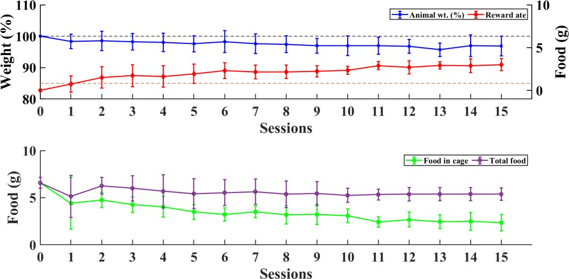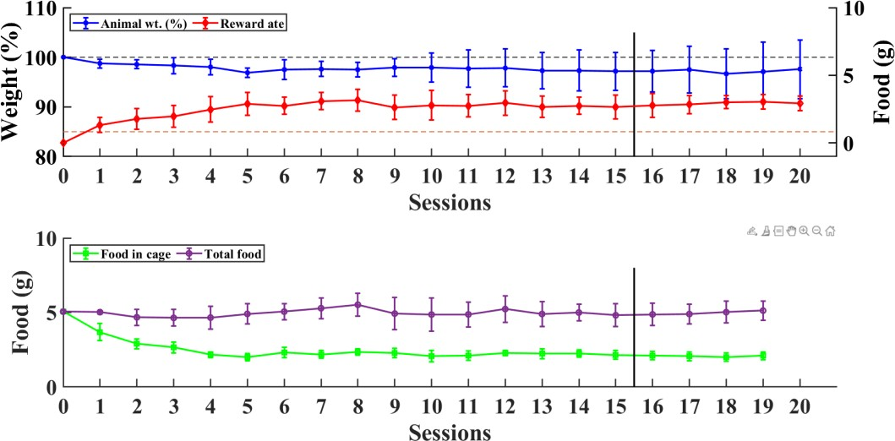

**(a)**

**(b)**

**Fig. 3.1. Bodyweight of the animals and daily food intake during foraging sessions in different foraging setups.** Average of animals‘ bodyweights in percentage (blue line) represented with the average consumption of rewards (red line); Average consumption of food kept in the cage after foraging session (green line) with average total food consumed (purple line) by the animals. All the four lines represent mean ± std. (n = 8). (a) Short box; (b) Long box,

16th

the line before foraging spouts.

session marks the start of foraging sessions with walls in between the

**21**

**3.2. SESSION-WISE ANALYSIS**

Altogether, five different foraging parameters (see Methods section **2.5.2** for definitions) were analyzed for overall sessions of all the animals in each setup (see

supplementary figures **S1-S10** in Appendix).

Prior to the start of the foraging sessions in the long box setup with walls, all the animals were already well trained for the foraging task in other two forms of the foraging setup. Therefore, all the sessions in this foraging setup were considered as the performing phase sessions and it is evident from the supplementary **fig. S10(C)** that the median of the travel time is always less than 5s for each session. Hence, the travel time of lesser than or equal to **5s** was considered as the criterion to separate the performing phase sessions from the non-performing phase sessions for

all the animals in each foraging setup.

Primarily, when the foraging tasks were performed in the short box without any walls in between the spouts, the foraging sessions **7-15** met the criterion for performing phase. Similarly, the foraging sessions **3-15** and **1-5** were the performing phase sessions for the long box experiments without and with the walls

respectively.

For all the parameters analyzed here, Wilcoxon rank-sum test was conducted to

check for the level of significant difference between the median of medians of the performing phase sessions of different foraging setups.

**22**

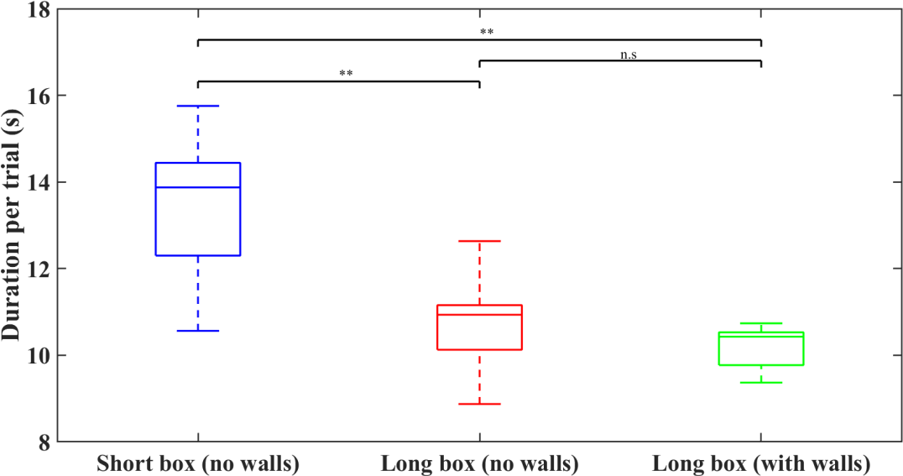

**3.2.1. TIME SPENT BY THE ANIMALS FOR NOSE POKING IN THE**

**FORAGING SPOUT**

In every trial, the animals spent some time at one of the foraging spouts for nose poking which was calculated as the difference between the times of the last poke

and the first poke in that trial.

**Fig. 3.2. Duration of nose-poking**

**at the foraging spout in performing phase sessions of**

**different foraging setups.** Box plots represent the median and inter-quartile range and the

significance bars indicate the differences given by Wilcoxon rank-sum test (p < 0.05 (*), p <

0.01 (**), p < 0.001 (***))

For nose poking, the animals spent a significantly longer time at the foraging spouts in the short box compared to both of the long box foraging setups (**fig. 3.2**). But, there was no significant difference between the two conditions in the long box

setup (with vs. without walls).

**23**

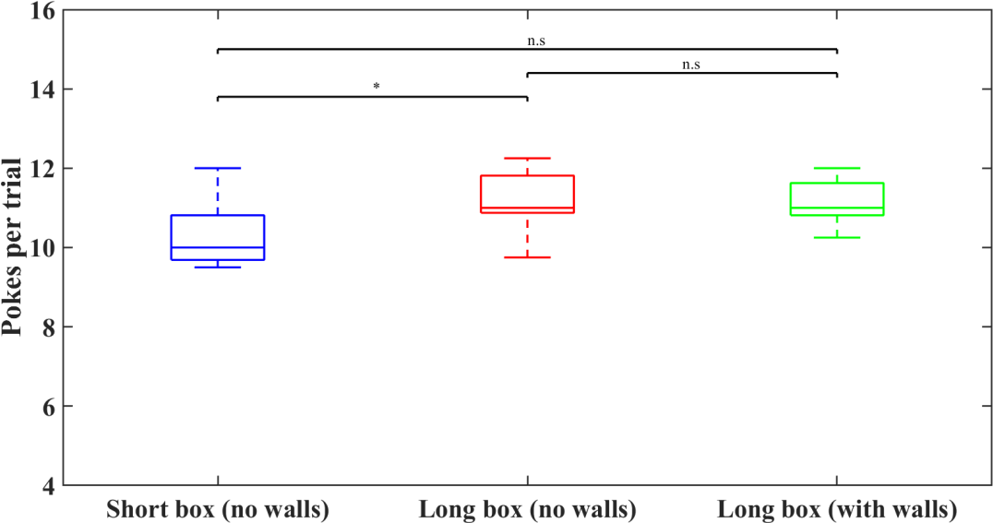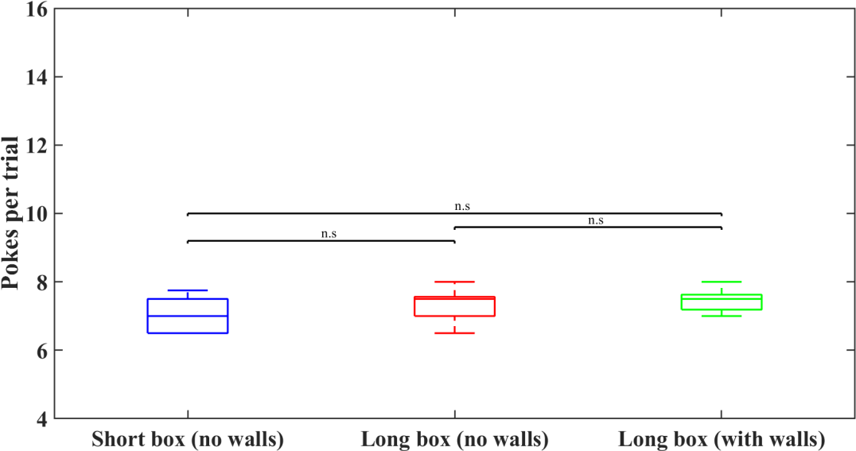

**3.2.2. NUMBER OF**

**FORAGING SPOUT**

**NOSE-POKES**

**MADE**

**BY**

**THE**

**ANIMALS**

**IN**

**THE**

**(a)**

**(b)**

**Fig.**

**3.3. Number of nose-pokes**

**in the foraging spout in performing phase sessions of**

**different foraging setups.** (a) Total number of nose-pokes (both hit and error pokes) made by the animals; (b) Total number of hit pokes made by the animals. Box plots represent the median and inter-quartile range and the significance bars indicate the differences given by Wilcoxon rank-sum test (p < 0.05 (*), p < 0.01 (**), p < 0.001 (***))

**24**

In search of a reward, the animals make numerous hit pokes and error pokes in each trial. The total number of nose-pokes (both hit and error pokes) made by the animals was significantly higher in the long box than the short box (**fig. 3.3 (a)**) when no walls were placed in between the foraging spouts. No significant

difference was found between the long box setup with and without walls.

In the case of considering only the number of hit pokes (**fig. 3.3 (b)**) made by the

animals, the median of all the foraging setups was highly similar — showing no significant effects in Wilcoxon rank-sum test.

**3.2.3. RATE OF NOSE POKING IN THE FORAGING SPOUT BY THE**

**ANIMALS**

The total number of nose-pokes and the time spent by the animals for nose poking in the foraging spouts determines the rate of nose poking which denotes the quickness of the animals in exploiting the foraging spouts. In both the instances of the total number of nose-pokes (both hit and error pokes) and the total number of hit pokes, the medians of the rate of nose poking were lower in the short box than

both the long box foraging setups.

It is also noticeable that the level of significant difference between the medians for all the three comparisons was the same (p < 0.01) for the poking rates in both the cases of the total number of nose-pokes (**fig. 3.4 (a)**) and the total number of hit

pokes (**fig. 3.4 (b)**).

**25**

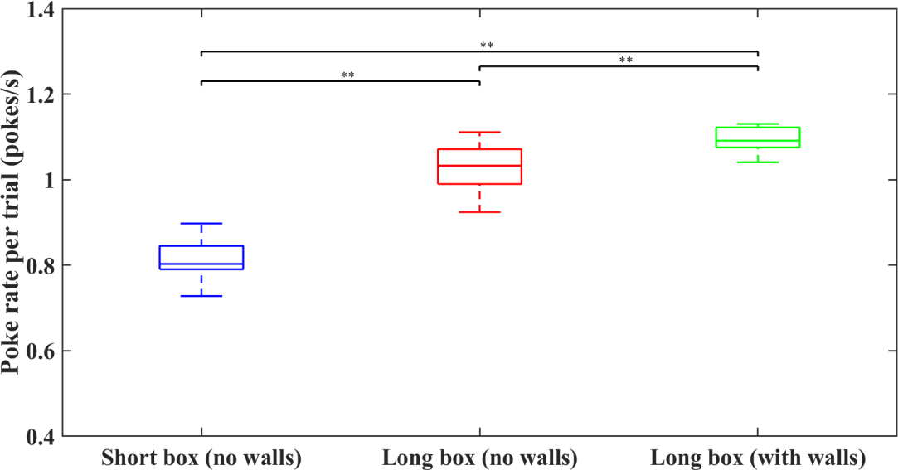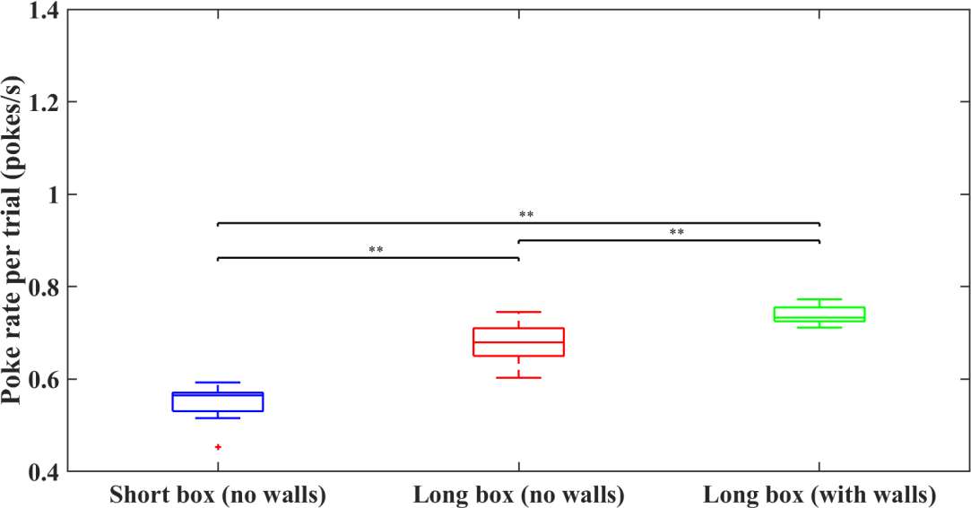

**(a)**

**(b)**

**Fig. 3.4. Rate of nose poking in the foraging spout in performing phase sessions of different foraging setups.** (a) Rate of nose poking for the total number of nose-pokes (both hit and error pokes) made by the animals; (b) Rate of nose poking for the total number of hit pokes made by the animals. Box plots represent the median and inter-quartile range and the significance bars indicate the differences given by Wilcoxon rank-sum test (p < 0.05 (*), p < 0.01 (**), p < 0.001 (***))

**26**

**3.2.4. INTER POKE INTERVALS BETWEEN THE SUCCESSIVE NOSE-**

**POKES IN THE FORAGING SPOUT**

During the course of a trial, the animals were rewarded with a food pellet or unrewarded for hit pokes based on the reward probability and reward outcome at that moment. Therefore, the animals tended to nose-poke the foraging spout after a rewarded hit poke in search of another reward or else seeking for a reward after an unrewarded hit poke. The time differences between the preceding hit poke and the

latter nose-poke were called as inter poke intervals.

When the preceding hit poke was rewarding (**fig. 3.5 (a)**), the inter poke intervals were higher in the long box foraging setup with walls compared to the setups without the walls. Also, the inter poke intervals in the short box were lesser than both of the long box foraging setups. The level of significant difference between the medians for all the three comparisons was also the same (p < 0.01). But in the event of unrewarded preceding hit pokes (**fig. 3.5 (b)**), no significant differences

were seen between the three foraging setups.

On enumerating the difference between the inter poke intervals of the two outcomes for the preceding hit poke (**fig. 3.6**), the median of the short box was significantly lesser than both the long box foraging setups as the medians of both

the long box foraging setups were almost equal.

**27**

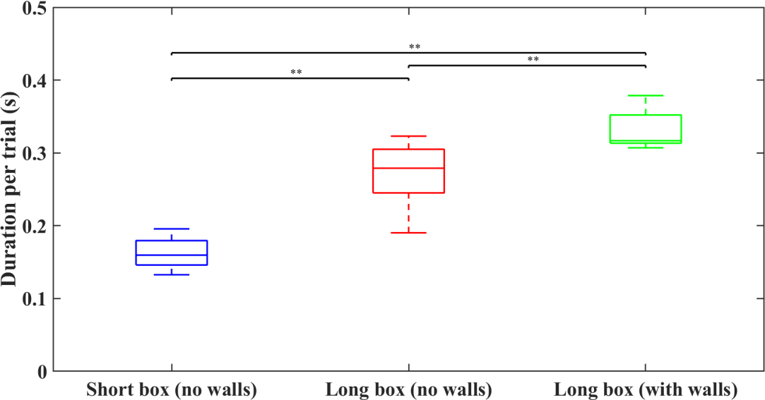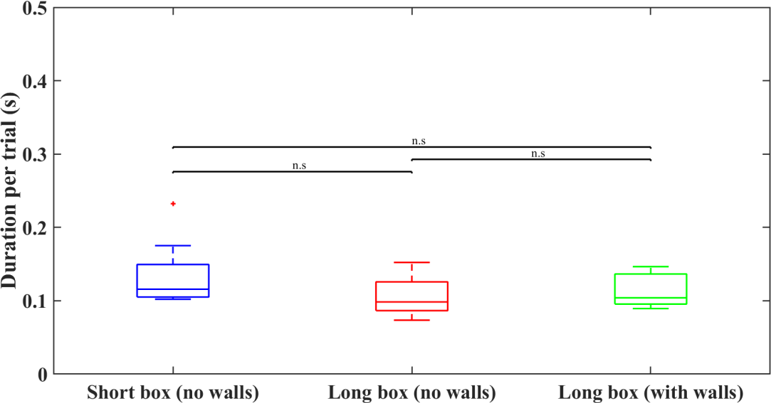

**(a)**

**(b)**

**Fig.**

**3.5. Inter poke interval between the successive nose-pokes in the foraging spout in**

**performing phase sessions of different foraging setups.** (a) Inter poke interval in which the

preceding hit poke was rewarded with a food pellet; (b) Inter poke interval in which the preceding hit poke was unrewarded. Box plots represent the median and inter-quartile range and the significance bars indicate the differences given by Wilcoxon rank-sum test (p < 0.05 (*), p <

0.01 (**), p < 0.001 (***))

**28**

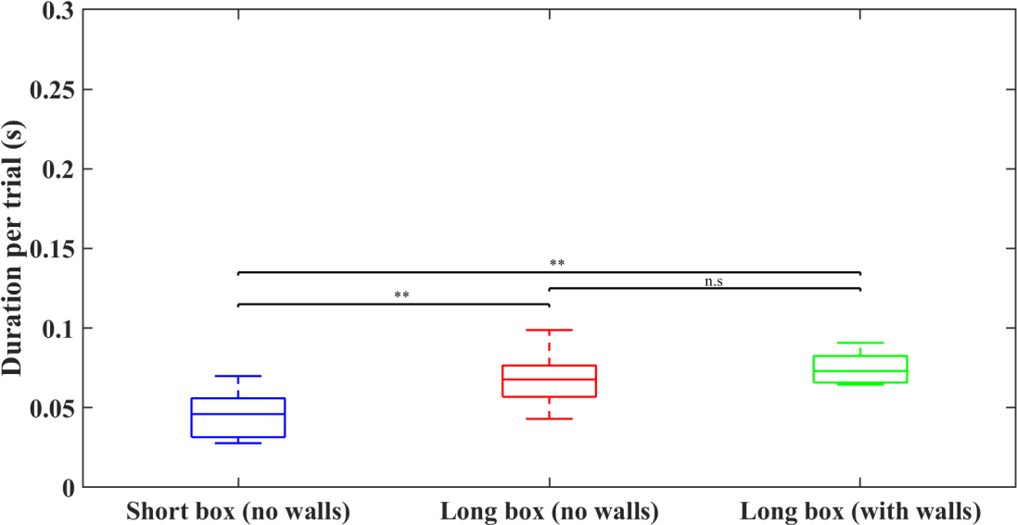

**Fig. 3.6. Difference between the inter poke intervals of rewarded and unrewarded preceding hit poke in performing phase sessions of different foraging setups**. Box plots represent the median and inter-quartile range and the significance bars indicate the differences given by Wilcoxon rank-sum test (p < 0.05 (*), p < 0.01 (**), p < 0.001 (***))

**3.2.5. TIME TAKEN BY THE ANIMALS TO TRAVEL FROM ONE SPOUT**

**TO ANOTHER SPOUT**

At the moment at which the animals want to stop exploiting the current foraging spout, they move towards another foraging spout placed at the opposite side of the foraging setup. The time taken by the animals to travel between the foraging spouts

was termed as travel time.

As we took the same decision criterion of travel time for all the foraging setups, we could not witness any significance difference between the medians of travel time

across different foraging setups (**fig 3.7**).

**29**

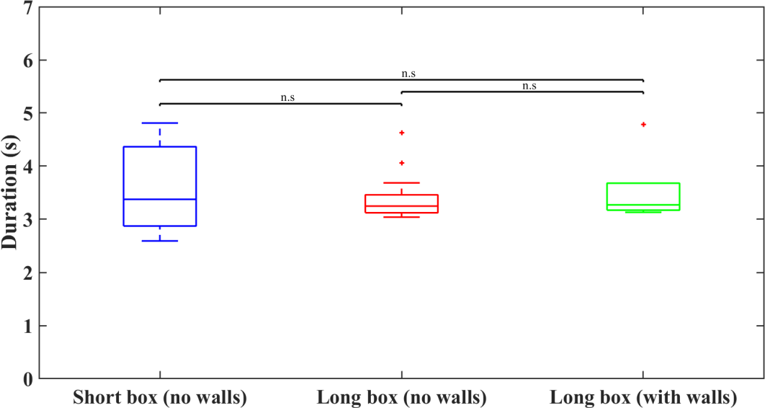

**Fig. 3.7. Time taken to travel between the foraging spouts in performing phase sessions of different foraging setups.** Box plots represent the median and inter-quartile range and the significance bars indicate the differences given by Wilcoxon rank-sum test (p < 0.05 (*), p <

0.01 (**), p < 0.001 (***))

**3.3. TRIAL-WISE ANALYSIS**

The individual trials in the performing phase sessions of each setup were enumerated, and five separate parameters (see Methods section **2.5.3** for definitions) were analyzed in each trial. For the foraging setups without any walls in between the spouts, 3100 trials and 4432 trials were observed for the short box and the long box respectively. In the case of the long box setup with walls, the trial

count was 1760 (see supplementary table **S16**).

The significance levels of difference were estimated using Wilcoxon rank-sum test for Bonferroni corrected significance values. The comparison was done across different setups for each trial type (starting reward probability) and also across different trial types for each setup. Simultaneously, a two-way ANOVA test was

conducted for each trial-based parameter.

**30**

**3.3.1. NUMBER OF NOSE-POKES MADE BY THE ANIMALS IN THE**

**FORAGING SPOUT**

To obtain a reward, the animals explored the foraging arena and exploited one of the foraging spouts by nose poking it. For comparison of the total number of nose- pokes between different foraging setups for the same trial type, a significant difference was seen only for the trial type with the starting probability A=0.5 (**fig.**

**3.8 (a)**) where the long box foraging setup with walls was seen significantly higher

than the rest of the two foraging setups.

Nevertheless, seven out of nine comparisons between different trial types for each foraging setup showed higher significant differences. In the two-way ANOVA for the main factors (setup type (ST) & trial type (TT)), the significant effects were found for ST: F2,9283= 7.73; **p=0.0004** and TT: F2,9283 = 114.42; **p<0.0001**, but no

significant interaction was found; ST x TT: F4,9283 = 0.91; **p=0.4543**.

On considering the number of hit pokes made by the animals (**fig. 3.8 (b)**), the long box foraging setup with walls significantly differed from both the setups without

walls for the trial types with the starting probabilities of A=1 and A=0.5.

Here also, the higher significance level of differences was seen for all of the comparisons between different trial types of the same foraging setup. In the two-

way ANOVA for the main factors (ST & TT), the significant effects were found

for ST:

F2,9283

= 10.55; **p<0.0001** and TT:

F2,9283

= 190.67; **p<0.0001**, but no

significant interaction was seen; ST x TT: F4,9283 = 0.97; **p=0.4209**.

**31**

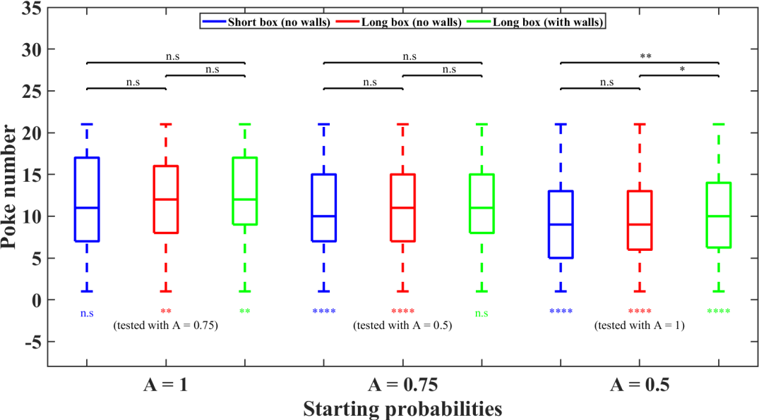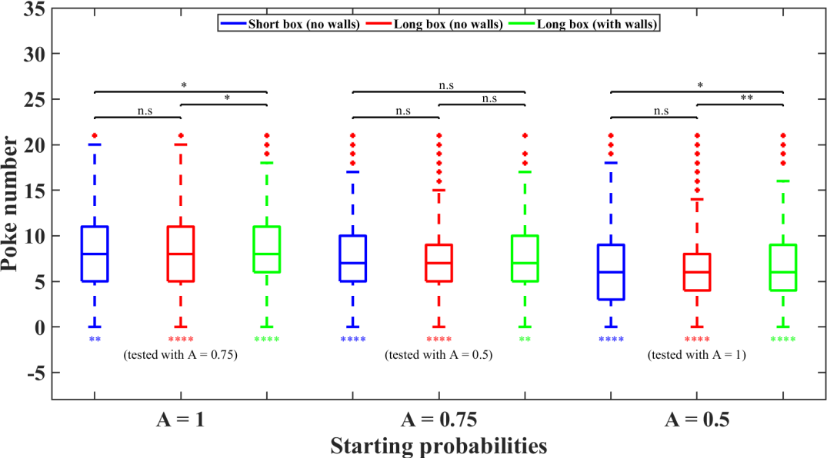

**(a)**

**(b)**

**Fig. 3.8. Number of nose-pokes in the foraging spout indifferent to trial types of performing phase sessions of different foraging setups.** (a) Total number of nose-pokes (both hit and error pokes) made by the animals; (b) Total number of hit pokes made by the animals. Box plots represent the median and inter-quartile range; the significance bars indicate the differences between different foraging setups for each trial type; the significance stars below each box plot represent the differences between different trial types (given in braces) for each setup given by Wilcoxon rank-sum test for Bonferroni corrected p-values (p <0.05/18(*), p < 0.01/18 (**), p < 0.001/18 (***), p < 0.0001/18 (****))

**32**

**3.3.2. NUMBER OF UNREWARDED NOSE-POKES MADE BY THE**

**ANIMALS AT THE FORAGING SPOUT**

Most of the nose-pokes at the foraging spout will be unrewarded as the probability of getting a reward decayed exponentially after each hit poke. On analyzing the number of unrewarded nose-pokes, the trial type with the starting probability of A=0.5 only showed a significant difference between the short box without walls and the long box with walls when all the types of unrewarded nose-pokes were

examined.

The other comparisons did not have any significant effect in Wilcoxon rank-sum

test for Bonferroni corrected p-values. In the two-way ANOVA for the main

factors (ST & TT), the significant effect was found only for ST:

F2,9283

= 3.39;

**p=0.0337** but not for TT: F2,9283 = 2.62; **p=0.0732**, also no significant interaction

was found; ST x TT: F4,9283 = 0.91; **p=0.4556** (**fig. 3.9 (a)**).

When the unrewarded hit pokes were taken alone, the two long box foraging setups differed significantly for the trial types with the starting probabilities of A=1 and A=0.5. In conjunction, the one significant difference seen for the unrewarded total number of nose-pokes was also observed for the unrewarded hit pokes. For the comparisons across different trial types in the matching foraging setup, the long box setup without walls exhibited a lower significant difference between the trial

types with starting probabilities of A=1 and A=0.75.

In the two-way ANOVA for the main factors (ST & TT), the significant effect was

found only for ST:

F2,9283

= 11.11; **p<0.0001** but not for TT:

F2,9283

F4,9283

= 2.96;

= 0.89;

**p=0.0519**, also no significant interaction was found;

**p=0.4718** (**fig. 3.9 (b)**).

ST x TT:

**33**

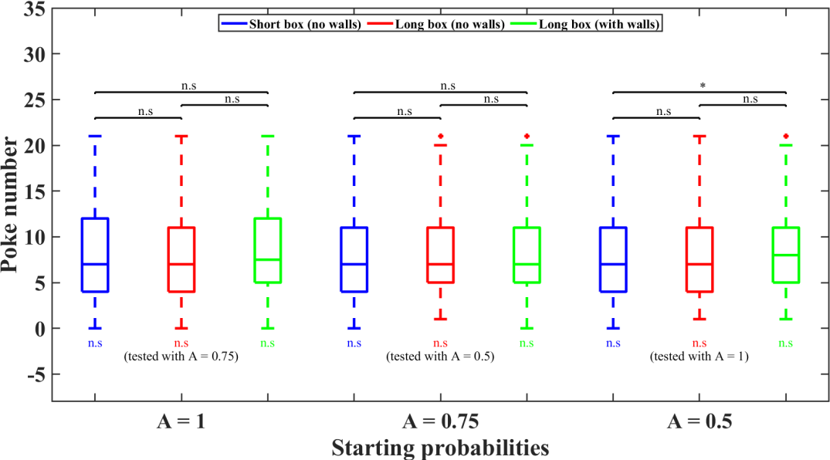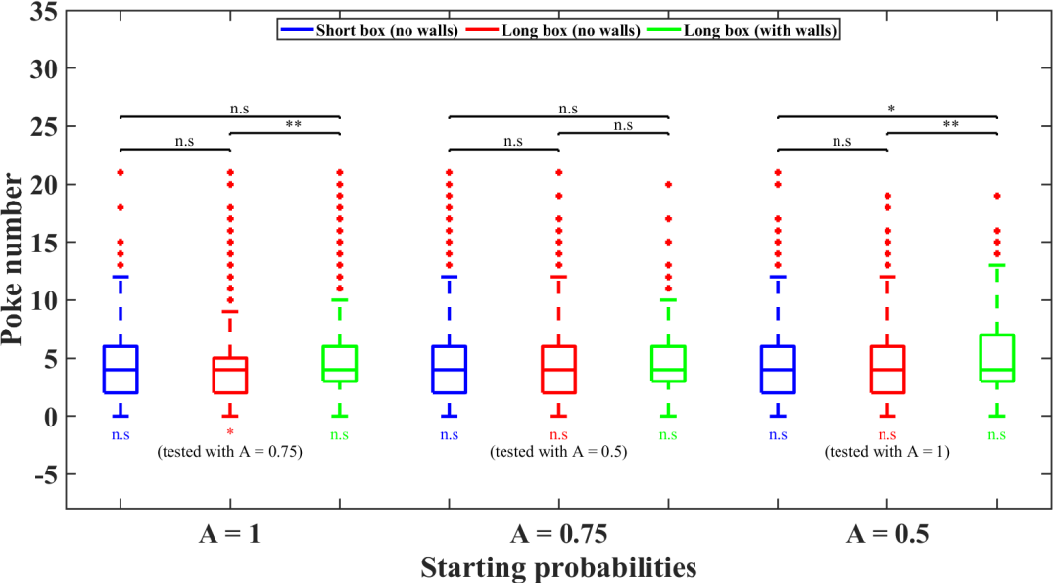

**(a)**

**(b)**

**Fig. 3.9. Number of unrewarded nose-pokes at the foraging spout in different trial types of performing phase sessions of different foraging setups**. (a) Total number of unrewarded nose- pokes (both hit and error pokes) made by the animals; (b) Total number of unrewarded hit pokes made by the animals. Box plots represent the median and inter-quartile range; the significance bars indicate the differences between different foraging setups for each trial type; the significance stars below each box plot represent the differences between different trial types (given in braces) for each setup given by Wilcoxon rank-sum test for Bonferroni corrected p- values (p < 0.05/18 (*), p < 0.01/18 (**), p < 0.001/18 (***), p < 0.0001/18 (****))

**34**

**3.3.3. NUMBER OF CONSECUTIVE UNREWARDED NOSE-POKES**

**MADE BY THE ANIMALS BEFORE LEAVING THE SPOUT**

In most of the trials, a consecutive number of unrewarded nose-pokes were

observed when the animals stopped exploiting the current foraging spout.

On

noticing both unrewarded hit and error pokes done consecutively before leaving the current foraging spout (**fig. 3.10 (a)**), no significant differences were seen

across the foraging setups for each trial type.

But for both the foraging setups without walls, significant differences were seen between the trial types with starting probabilities of A=0.5 and A=1. In the two- way ANOVA for the main factors (ST & TT), the significant effects were found for ST: F2,9283 = 4.56; **p=0.0105** and TT: F2,9283 = 8.78; **p=0.0002**, but no significant

interaction was seen; ST x TT: F4,9283 = 0.78; **p=0.5394**.

When consecutive unrewarded hit pokes were only considered, significant differences were seen between the long box setups for the trial types with the starting probabilities of A=1 and A=0.5 (**fig. 3.10 (b)**). For all the foraging setups, significant differences were observed between the trial types with starting probabilities of A=0.5 and A=1. In the short box setup alone, a difference was seen

also between A=1 and A=0.75.

In the two-way ANOVA for the main factors (ST & TT), the significant effects were found for ST: F2,9283 = 9.67; **p=0.0001** and TT: F2,9283 = 10.28; **p<0.0001**, but

no significant interaction was seen; ST x TT: F4,9283 = 1.68; **p=0.1508**.

**35**

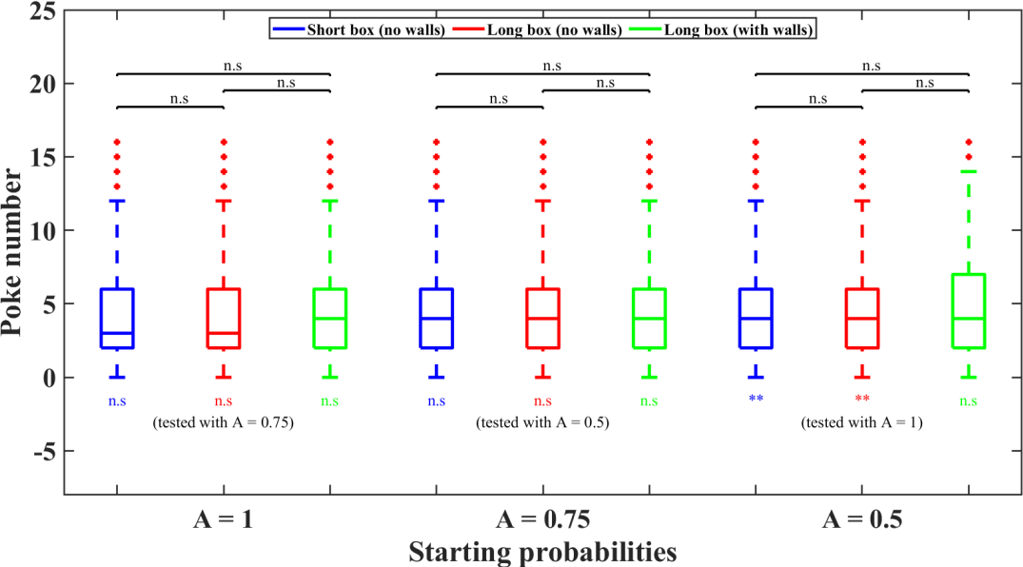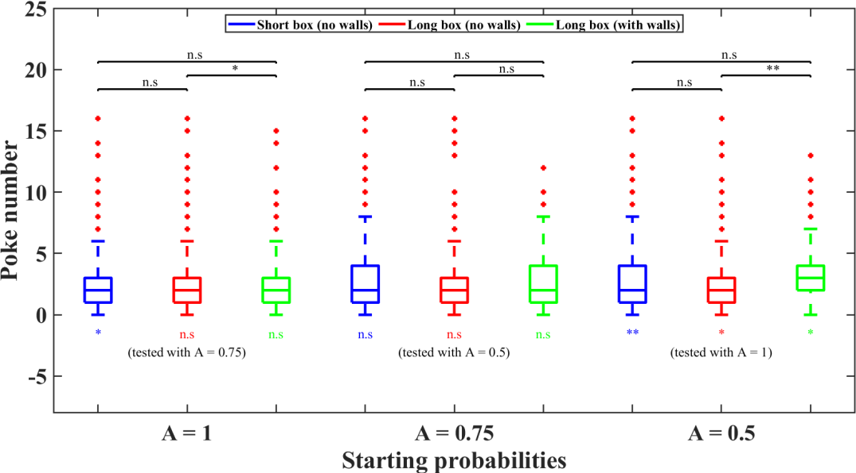

**(a)**

**(b)**

**Fig. 3.10. Number of consecutive unrewarded nose-pokes before leaving the foraging spout in different trial types of performing phase sessions of different foraging setups.** (a) Total number of consecutive unrewarded nose-pokes (both hit and error pokes) made by the animals;

(b) Total number of unrewarded consecutive hit pokes made by the animals. Box plots represent the median and inter-quartile range; the significance bars indicate the differences between different foraging setups for each trial type; the significance stars below each box plot represent the differences between different trial types (given in braces) for each setup given by Wilcoxon rank-sum test for Bonferroni corrected p-values (p < 0.05/18 (*), p < 0.01/18 (**), p < 0.001/18 (***), p < 0.0001/18 (****))

**36**

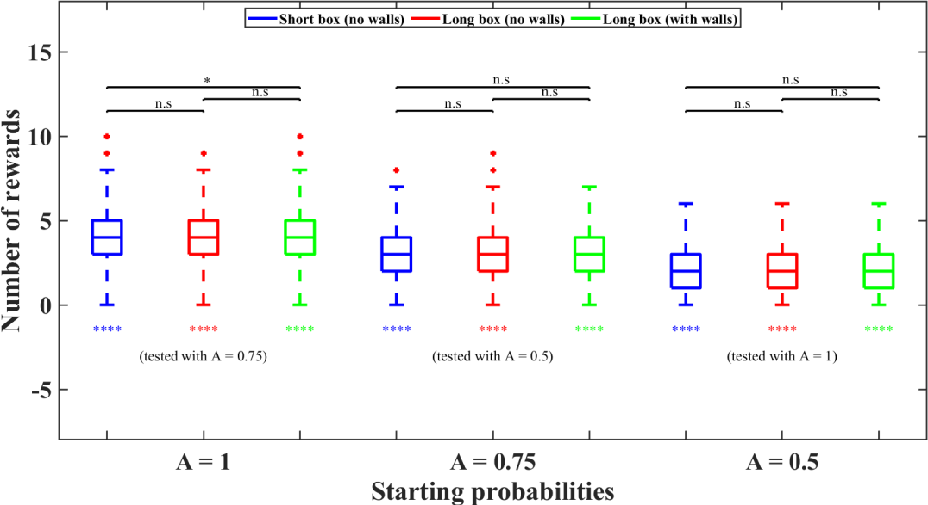

**3.3.4. NUMBER OF REWARDS OBTAINED BY THE ANIMALS**

Based on the reward probability and reward outcome, hit pokes were rewarded with a food pellet. On comparing the number of rewards obtained in each trial across different foraging setups in the same trial types, only one comparison in the trial type with the starting probability of A=1 showed a lower significant effect. On the other hand, all the comparisons across different trial types in the same foraging setup showed higher significance differences. In the two-way ANOVA for the main factors (ST & TT), the significant effects were found for ST: F2,9283 = 7.43;

**p=0.0006** and TT: F2,9283 = 1347.91; **p<0.0001**, but no significant interaction was

seen;

ST x TT: F4,9283 = 0.87; **p=0.4832**.

**Fig. 3.11. Number of rewards obtained in different trial types of performing phase sessions of different foraging setups.** Box plots represent the median and inter-quartile range; the significance bars indicate the differences between different foraging setups for each trial type; the significance stars below each box plot represent the differences between different trial types (given in braces) for each setup given by Wilcoxon rank-sum test for Bonferroni corrected p- values (p < 0.05/18 (*), p < 0.01/18 (**), p < 0.001/18 (***), p < 0.0001/18 (****))

**37**

**3.3.5. POKE NUMBER OF THE FIRST REWARD OBTAINED BY THE**

**ANIMALS**

When the first reward was observed by considering both the hit and error pokes (**fig. 3.12 (a)**), a significant difference was seen between the short box and both the long box foraging setups in the trial type with the starting probability of A=1. Similarly, a high level of significant difference was observed in each setup between the trial types with starting probabilities of A=1 and A=0.75 & A=0.5 and

A=1. In the two-way ANOVA for the main factors (ST & TT), the significant

effects were found for ST:

F2,9283

= 5.31; **p=0.005** and TT:

F2,9283

= 173.88;

**p<0.0001**, but no significant interaction was seen; ST x TT:

**p=0.2862**.

F4,9283

= 1.25;

On noticing the first rewarded hit poke (**fig. 3.12 (b)**), the comparison between different setups in the same trial type showed a similar kind of difference. For the other set of comparisons between the trial types of the same foraging setup, most

of them had a high level of significant differences.

In the two-way ANOVA for the main factors (ST & TT), the significant effects

were found for ST: F2,9283 = 4.26; **p=0.0141** and TT:

F2,9283

= 304.23; **p<0.0001**,

but no significant interaction was seen; ST x TT: F4,9283 = 0.81; **p=0.5204**.

**38**

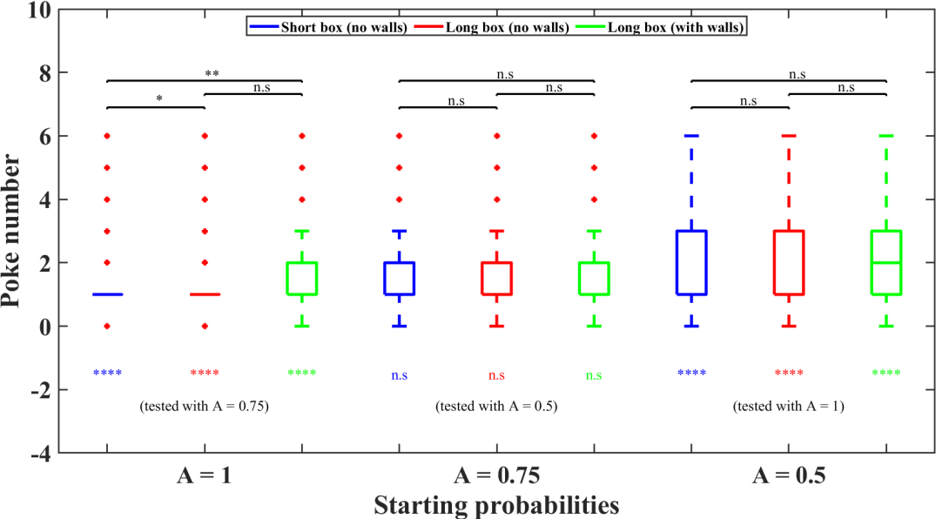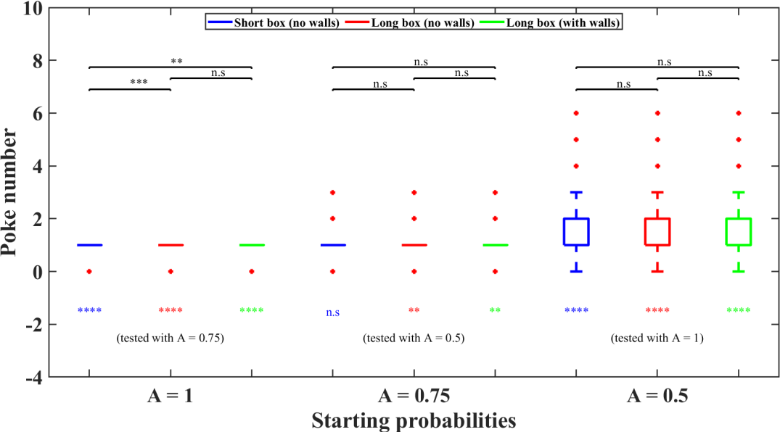

**(a)**

**(b)**

**Fig. 3.12. Poke number of the first reward in different trial types of performing phase sessions of different foraging setups.** (a) Total (both hit and error pokes) poke number of the first reward obtained by the animals; (b) Hit poke number of the first reward obtained by the animals. Box plots represent the median and inter-quartile range; the significance bars indicate the differences between different foraging setups for each trial type; the significance stars below each box plot represent the differences between different trial types (given in braces) for each setup given by Wilcoxon rank-sum test for Bonferroni corrected p-values (p < 0.05/18 (*), p < 0.01/18 (**), p < 0.001/18 (***), p < 0.0001/18 (****))

**39**

**4. DISCUSSION**

All organisms must make decisions for their survival while facing uncertainty in their environment. Animals and humans tend to perform actions that are likely to lead to desirable outcomes. But they must also consider the possibility that environmental conditions may change and outcomes of their actions may vary over time. Such behavioral flexibility requires a delicate balance between harnessing (exploiting) known resources and exploring alternative options that may become beneficial. The trade-off between exploration and exploitation can be seen as a

challenge for the allocation of attentional resources.

Foraging behavior in Mongolian gerbils is a suitable model to study such flexible behavioral strategies. When a foraging site is depleted, the gerbil is in an exploitation/exploration dilemma. Should current attentional resources be used to continue foraging at the current site, or should the environment be explored for alternative options, i.e., moving on to the next foraging area, at a time cost to the gerbil but enjoying potentially higher foraging density (cf. Shuai & Song, 2011)? This decision must be made based on probabilistic information (how much reward is typically available in the alternative area?). The trade-offs between exploration and exploitation has been studied in many animal species, in different domains, and with numerous paradigms (marginal value theorem, MVT; Charnov, 1976; Constantino & Daw, 2015). The behavior of all species, from insects to birds to mammals and humans, obeys the MVT, indicating basic behavioral patterns and

possible conserved neural mechanisms.

In this study, a probabilistic foraging paradigm was established in Mongolian

gerbils along with developing a food restriction regime convenient for the animals

**40**

that helped in enhancing the motivation of the animals to perform well in the

probabilistic constructed

probabilistic

foraging task. In total, three different foraging setups were and food-restricted Mongolian gerbils (n=8) were put in the

foraging paradigm to receive food pellets as the rewards based on

their decisions to exploit and explore the foraging spouts in the setup. At first, the animals were trained in the short box foraging setup in which no walls were kept in between the foraging spouts, followed by a resting period for few weeks. Then the animals were placed in the long box foraging setup and foraging sessions were

accomplished without and with walls consecutively.

The quantitative analysis of different foraging parameters was done using various statistical methods (Wilcoxon rank-sum test, two-way ANOVA) to enumerate the optimal food quantity needed for the gerbils during the foraging task, and animals‘ behavior in various trial types in different forms of the foraging setup which will be discussed in this section to evaluate the probabilistic foraging paradigm in

Mongolian gerbils aided by the food restriction practices on them.

**4.1. FEEDING OF THE ANIMALS**

The animals received their food as rewards (20mg food pellets) during the foraging task and normal food pellets that were kept inside their cages to maintain the bodyweights above the critical level of 85% (Kvitsiani et al., 2013). In all forms of the foraging setup, the average reward intake increased in successive sessions and the average total daily food consumption was about 4-7g depending upon the animals‘ performances in the foraging task. Except for few sessions, the bodyweights of all the animals were seen above 90% of BBW (**fig. 3.1 (a),(b)**). On average, all the animals performed more than 40 trials (supplementary **fig. S1**)

after they had learnt the foraging task well — which was sufficient (60 trials were

**41**

taken for analysis in Lottem et al., 2018) for analyzing the performance of the animals in the probabilistic foraging task. Therefore, the implementation of a food restriction regime on Mongolian gerbils (Tolnai et al., 2017) had worked properly in encouraging the animals to do more trials in the foraging task and also in

keeping the bodyweight of the animals in check.

**4.2. PERFORMANCE OF THE ANIMALS IN DIFFERENT FORAGING**

**SETUPS**

Five foremost foraging parameters were taken for analyzing the behavioral performances of the animals in the probabilistic foraging task. As the short box foraging setup (without walls) was novel for the animals, the duration of foraging spout exploitation was higher in this setup comparing to the other two foraging setups (supplementary **fig. S2**). Although the total number of nose-pokes and the total number of hit pokes were highly similar in all three foraging setups (supplementary **fig. S3 & S4**), the animals have nose poked much faster in both of the long box foraging setups (supplementary **fig. S5& S6**). Similar to the time taken for exploitation, the inter poke intervals (both rewarded and unrewarded preceding hit poke) and the travel time parameters also appeared to be high in the short box foraging setup (supplementary **fig. S7 - S10).** The medians of all the foraging parameters observed in the latter part of the foraging task in the short box setup were quite similar to the medians seen in the long box setup which shows that the animals had adapted some learning strategies during the latter part of foraging sessions in the short box setup which they implemented throughout the

foraging sessions of the long box setup.

Among all the analyzed foraging parameters, the travel time seemed to be a good

estimate for identifying the performing phase sessions of the animals in each

**42**

foraging setup (see Results section **3.2**). Similar to the trend of overall sessions, the exploitation time duration in performing phase sessions was significantly higher in the short box (**fig 3.2**) which could be due to the learning effect on animals. It is evident from these results that the exploitation time reduced as the animals learned

the foraging task well.

The poking rate (**fig 3.4**) of the animals signifies that when the travel distance was increased, the animals poked quickly in search of a reward. The inter poke interval after a rewarded preceding hit poke (**fig 3.5 (a)**) had the same outcome of the exploitation period. This leads to the speculation that animals briskly search for their rewards and also take more time to consume the food pellets received as the rewards in long box foraging setups. As expected there was not that much difference between the travel times among different setups in performing phase sessions since we considered the travel time (5s) as the decision criterion for

recognizing the performing phase sessions of the animals in each foraging setup.

**4.3. PERFORMANCE OF THE ANIMALS IN DIFFERENT TRIAL TYPES**

**OF THE PROBABILISTIC FORAGING TASK**

For a comprehensive understanding of the behavior of the animals, the individual trials in the performing phase sessions of each setup were examined. Especially the trials of the three different trial types were taken into consideration. In each setup, the amount of poking (**fig 3.8**) done by the animals significantly differed highly between the trial types as the animals poked in fewer numbers in trial types with lower starting probabilities. This could be due to the availability of more rewards

in trial type with higher starting probabilities (**fig 3.11**).

As most of the nose-pokes in the foraging spouts were unrewarded (**fig 3.9**) due to

the exponentially decaying nature of reward probabilities, more trials were

**43**

observed in the performing phase sessions in each foraging setup (supplementary **fig. S1**) indicating the tendency of the animals to explore the foraging spouts alternatively. Interestingly, the animals made a similar amount of unrewarded nose-pokes consecutively before leaving the foraging spouts in all of the trial types of different foraging setups. Therefore, the probability of the animals‘ eagerness to leave the foraging spout after a sequence of unrewarded nose-pokes can be

predicted from the supplementary **fig. S14**.

According to the design of the trial types in the probabilistic foraging paradigm, the trial type with the starting probability of A=1 was rewarded in the first hit poke which was almost the same in the case of the trial type with the starting probability of A=0.75 since most of the trials in this trial type were also rewarded for its first hit poke (fig. **3.12 (b)**). The first reward in the first hit poke itself could have also influenced the food-restricted animals to poke more times in the foraging spout in

the trial type with higher starting probabilities.

In the analysis of the individual trial types, highly significant differences were mostly seen between the trial types of the same kind of foraging setup for all of the trial-wise parameters. In contrast, the comparison between different foraging setups for the same trial type did not show many significant differences. On putting together the results obtained from both the analysis of session-wise and trial-wise parameters, few differences were seen between the foraging setups in the performing phase sessions. Overall, the result of the study could reveal that the change in travel distance between the foraging spouts by using different foraging arena architectures had only a minor impact on the foraging behavior of the food-

restricted Mongolian gerbils.

**44**

**4.4. EVALUATION OF THE PROBABILISTIC FORAGING PARADIGM**

**IN FOOD-RESTRICTED MONGOLIAN GERBILS**

In this study, the animal received the food both inside the foraging setup and also in the home cage. This lineated with the open economy policy of feeding the animals — where food was provided in limited amounts at least 2 hours after the foraging session and this does not affect the animals‘ performances in the

probabilistic foraging task (Fantino & Abarca, 1985).

Animals forage in their habitat for survival and the Marginal value theorem (MVT) describes the optimal strategy which decides the point of leaving when the instantaneous rate of rewards drops below its average value (Charnov, 1976). As the MVT assumptions were not realistic in the actual environment, another optimal solution remains relevant (Lottem et al., 2018). In accordance with this, the switching decisions between the foraging spouts were made in this probabilistic foraging task by the Mongolian gerbils. To be precise, the foraging behavior exhibited by the animals in the foraging setups could be explained by the diffusion decision models (Drugowitsch et al., 2019) in which decisions were made based on the trial-by-trial feedback during foraging sessions as each foraging approach (trial) was uncertain for the animals in the probabilistic foraging task. In this experiment, the rewards (food pellets) hold the key (for uncertainty) to such

decision making (Vertechi et al., 2020).

The switching between the foraging spouts, as observed in the presented study, could be seen as flexible allocation of attentional resources in which the anterior prefrontal cortex is considered as a crucial brain structure for the neural realization of exploratory resource allocation in humans (Daw et al., 2006), non-human

primates (Mansouri et al., 2015), and rodents (Kvitsiani et al., 2013).

**45**

Whenever the travel distance was increased, the time spent by the animals at the foraging spouts should have increased (Fantino & Abarca, 1985), and facing various travel distances, animals could adopt various strategies for maximizing their rewards (Shuai & Song, 2011). But, in the present foraging experiments, the time spent at the foraging spouts (**fig. 3.2 & S2**) decreased in the long box foraging setups which takes more time for the animals to alternate between the foraging

spouts. This complies with the learning behavior of the Mongolian gerbils (Cheal,

1986) as we Nevertheless,

setups.

used the same animals in all the foraging setups consecutively.

this

could

be

rectified

by

using

novel

animals

in

various

foraging

**46**

**5. CONCLUSION**

The food restriction regime had been successful in the Mongolian gerbils and that helped the animals to perform well in the probabilistic foraging paradigm (cf. Lottem et al., 2018) in all of the three types of foraging setups. In the travel-time- dependent, performing phase sessions, the post-hoc Wilcoxon rank-sum test, assisted by the two-way ANOVA test, revealed that the variation in travel distance between the foraging spouts affects the animals‘ behavior in the foraging task very

minimally.

**5.1. PERSPECTIVES**

This thesis was a pilot study in developing the probabilistic foraging paradigm for the food-restricted Mongolian gerbils. The ultimate goal of the present experimental project is to pave the way for investigating the basic brain processing principles of attentional resource allocation through a novel approach of combining a foraging behavioral experiment (Lottem et al., 2018) with *in vivo* physiology

(Zempeltzi et al., 2020) in a laboratory rodent model (Mongolian gerbil).

In order to achieve this, chronic electrodes will be implanted in the anterior prefrontal cortex (aPFC) of the Mongolian gerbils and an electrophysiological recording unit will be incorporated with the foraging setup to record local field potentials (LFPs). From the aPFC, LFPs will be analyzed to visualize the current source density (CSD) profiles of the Mongolian gerbils performing the

probabilistic foraging task.

One other important prospect is finding out a criterion based on the foraging

behavioral

parameters

to

distinguish exploration

and

exploitation

in

the

probabilistic foraging task. With this criterion, we will be able to create a better

**47**

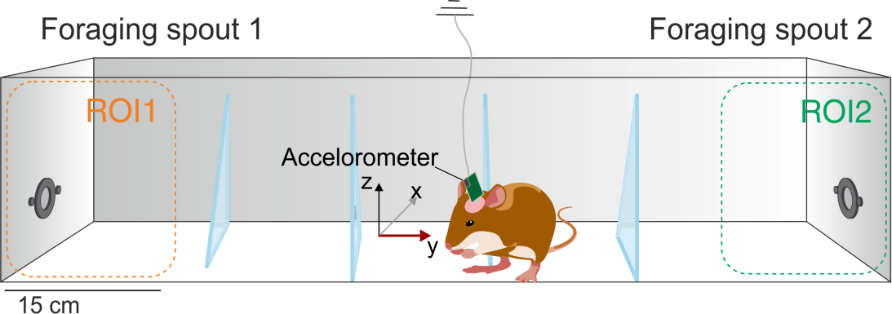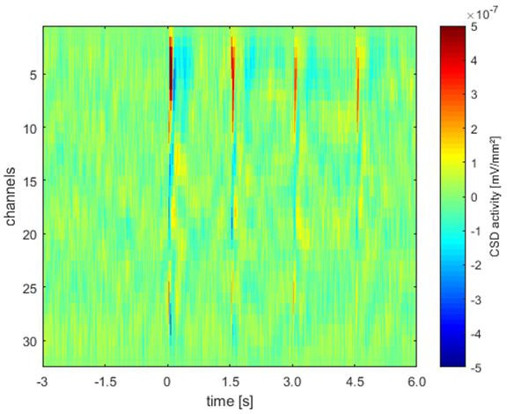

model for understanding the exploration and exploitation behavior that enables us

to study the attentional

prefrontal cortex.

resource

allocation

processes

occurring

in

the

anterior

**(a)**

**(b)**

**Fig. 5.1. Perspectives. (a) Multichannel recordings from aPFC of the Mongolian gerbil performing the probabilistic foraging task; (b) An example of a CSD profile relating to synaptic subpopulation activity in aPFC**

**48**

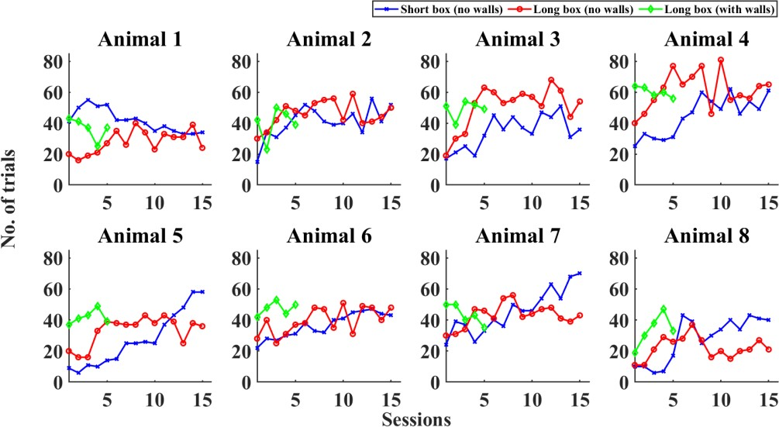

**6. APPENDIX**

**A. SUPPLEMENTARY FIGURES**

**A.1. SESSION-WISE ANALYSIS**

**Fig. S1. Number of trials done by the animals in each session in three different foraging setups.** 15 sessions were taken for both short box (Blue) and long box (Red) foraging tasks done without any walls in between the spouts; 5 sessions for long box (Green) setup with walls in between the spouts.

The following figures represent the results of session-wise analysis done for the nine parameters for each foraging setup. Every box plot constitutes for the median (middle line), 25th percentile (lower line), 75th percentile (upper line), lowest data point (lower whisker), largest data point (upper whisker), and outliers (red-colored

**+** symbols) of each parameter in each session for all animals (n=8). The dots depict the median of each animal for that particular session. In every figure, A (Blue) denotes the short box without any walls in between the spouts; B (Red) stands for the long box without any walls in between the spouts, and C (Green) marks the

long box with walls in between the spouts.

**49**

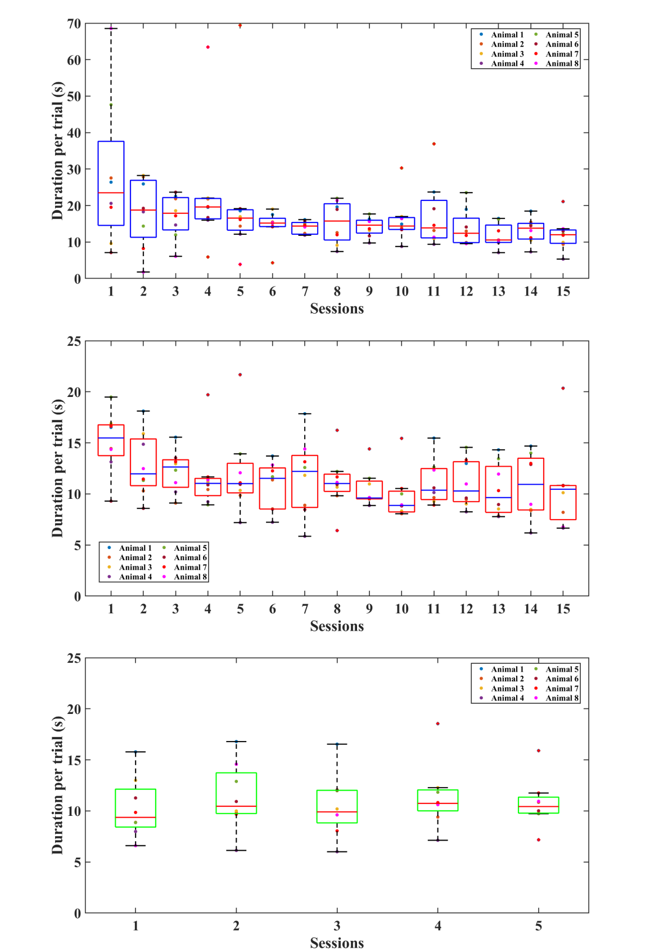

**A**

**B**

**C**

**Fig. S2. Time (in s) spent by the animals for nose poking in the foraging spout**

**50**

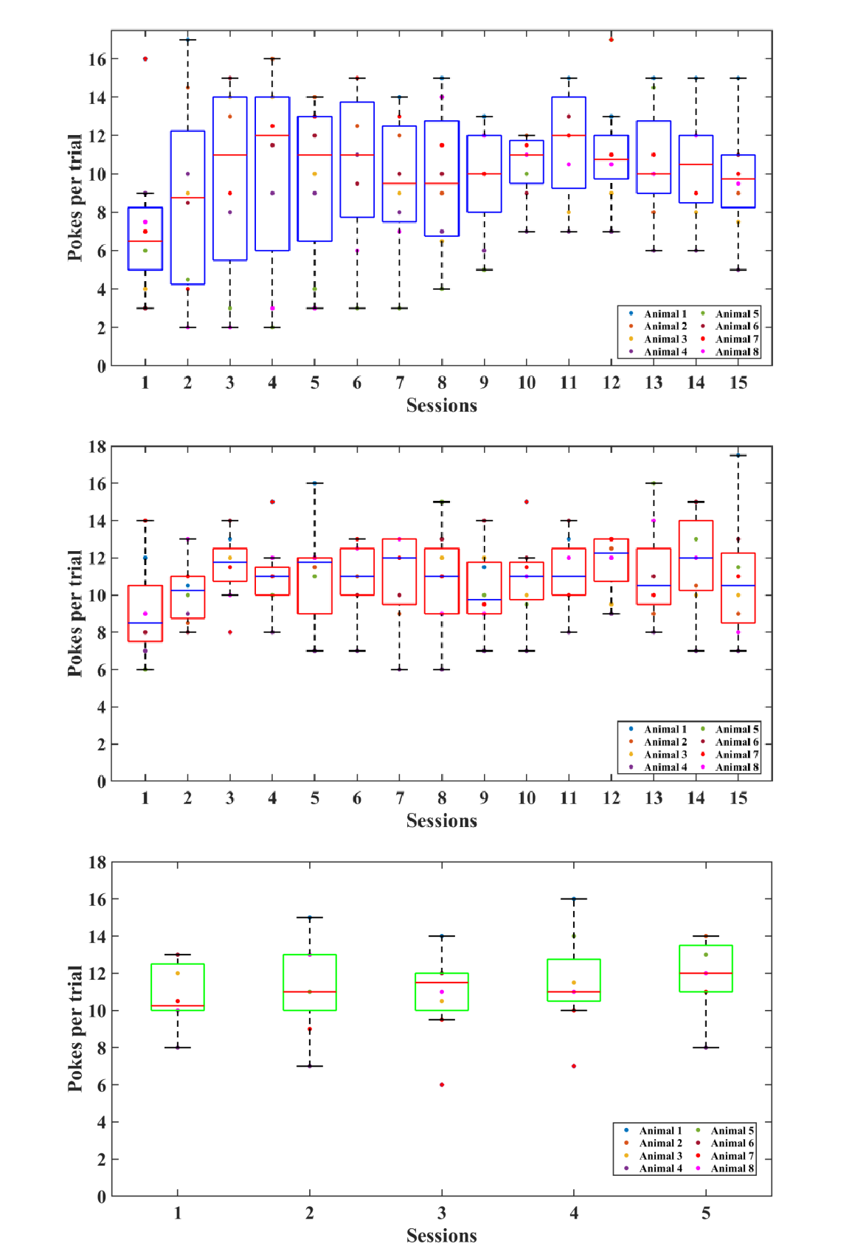

**A**

**B**

**C**

**Fig. S3. Total number of nose-pokes (both hit and error pokes) done by the animals**

**51**

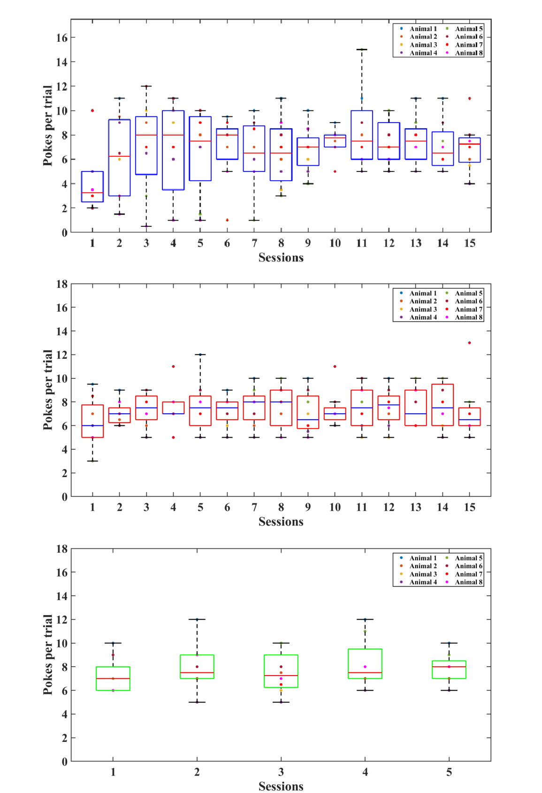

**A**

**B**

**C**

**Fig. S4. Total number of hit pokes done by the animals**

**52**

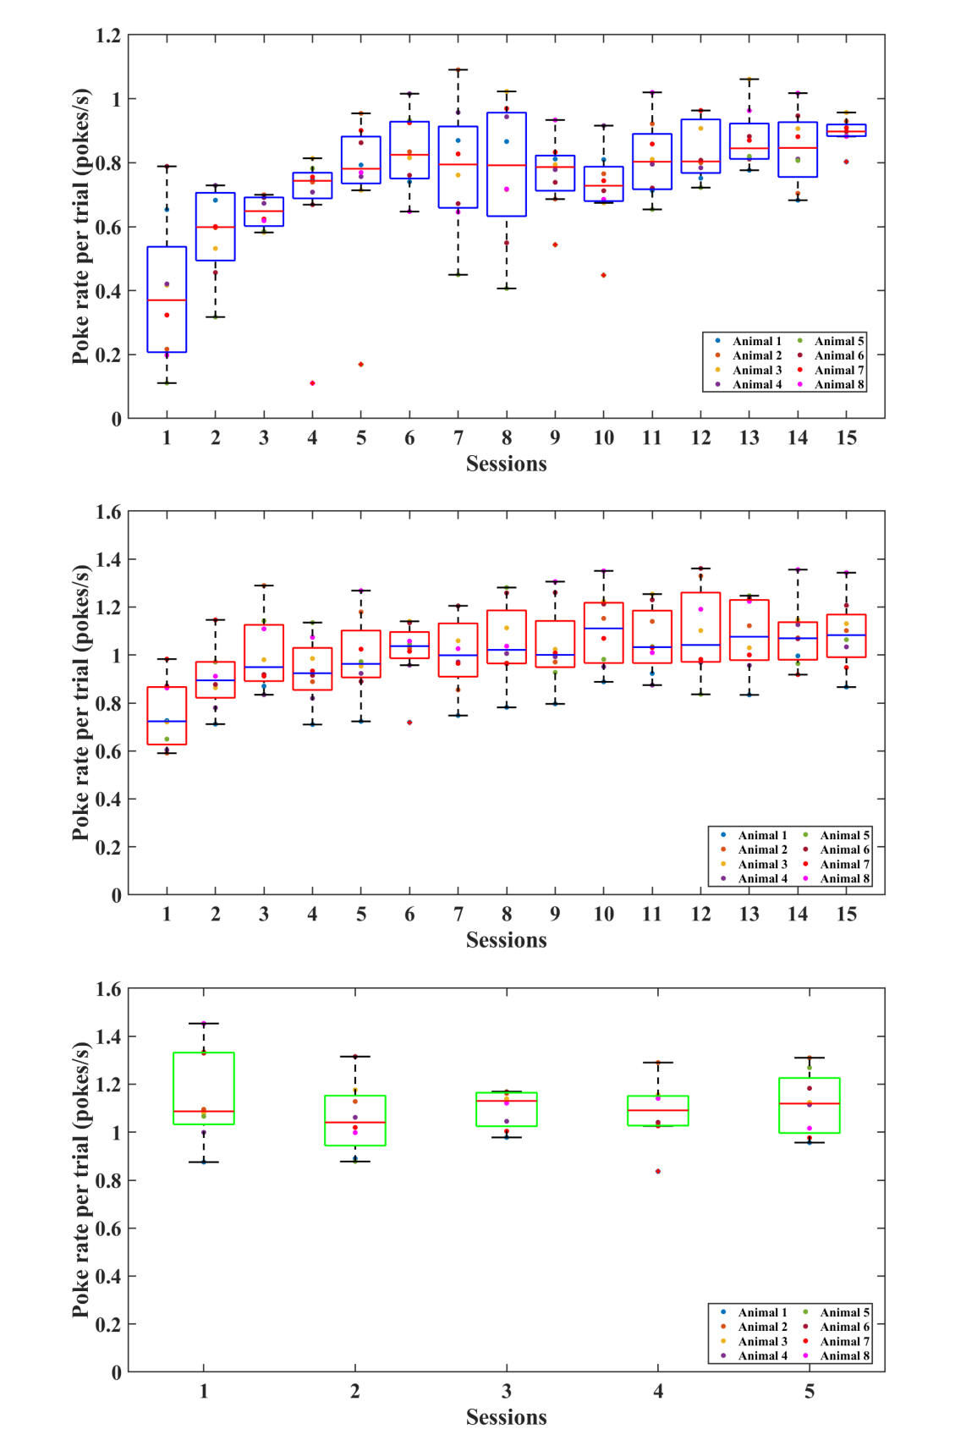

**A**

**B**

**C**

**Fig. S5. Poke rate (pokes/s) of the total number of nose-pokes (both hit and error pokes) done by the animals**

**53**

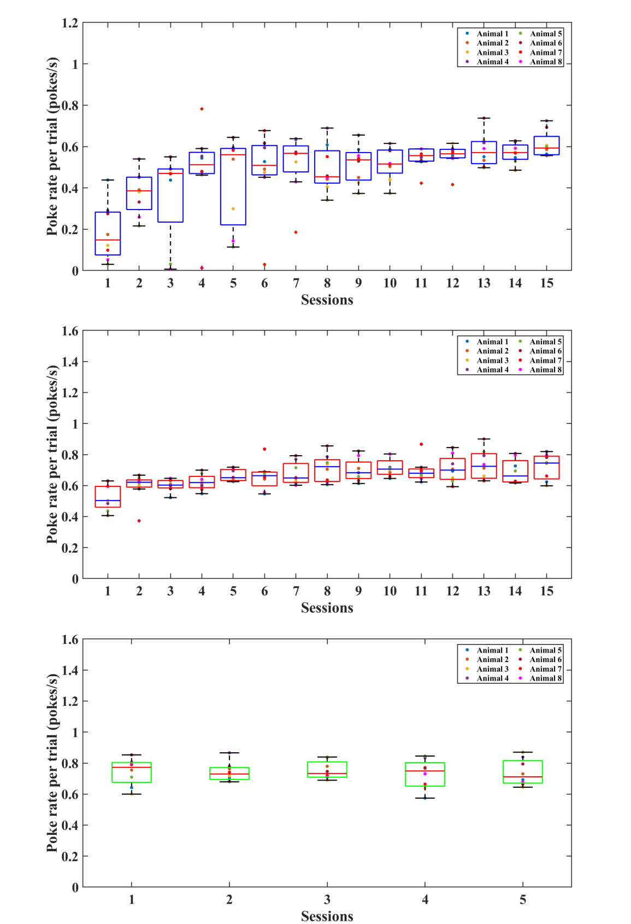

**A**

**B**

**C**

**Fig. S6. Poke rate (pokes/s) of hit pokes done by the animals**

**54**

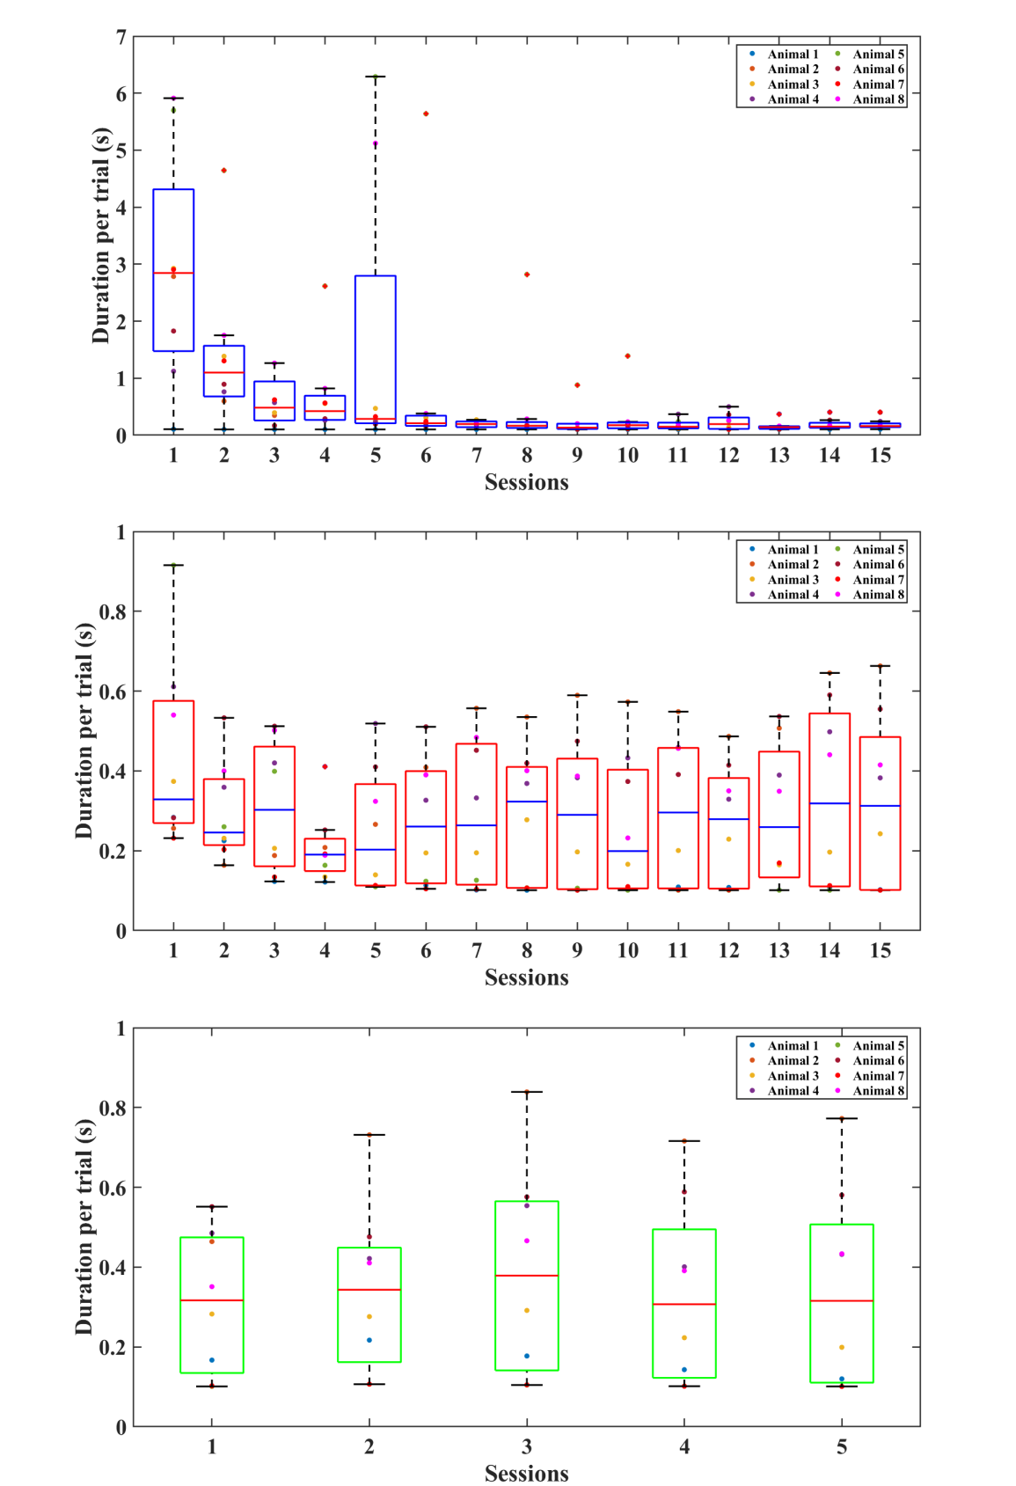

**A**

**B**

**C**

**Fig. S7. Inter poke interval (in s) in which preceding hit poke was rewarded**

**55**

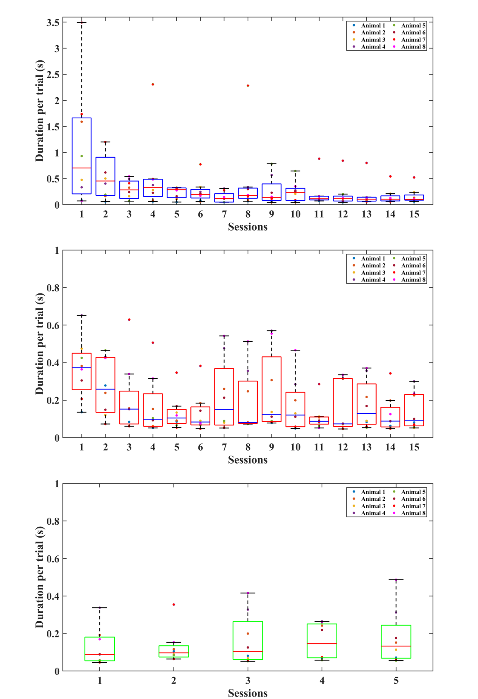

**A**

**B**

**C**

**Fig. S8. Inter poke interval (in s) in which preceding hit poke was unrewarded**

**56**

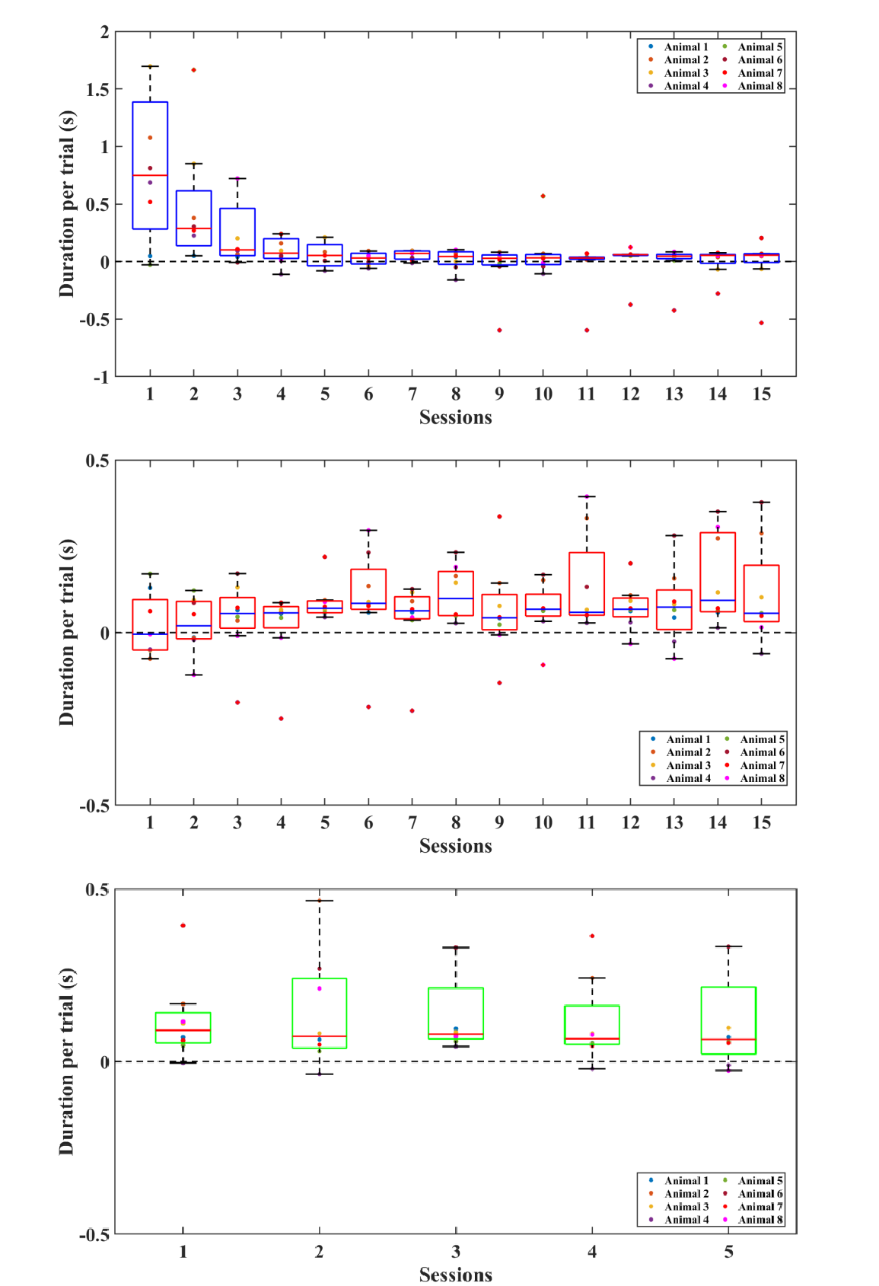

**A**

**B**

**C**

**Fig. S9. Difference between inter poke intervals (in s) of rewarded and unrewarded preceding hit poke**

**57**

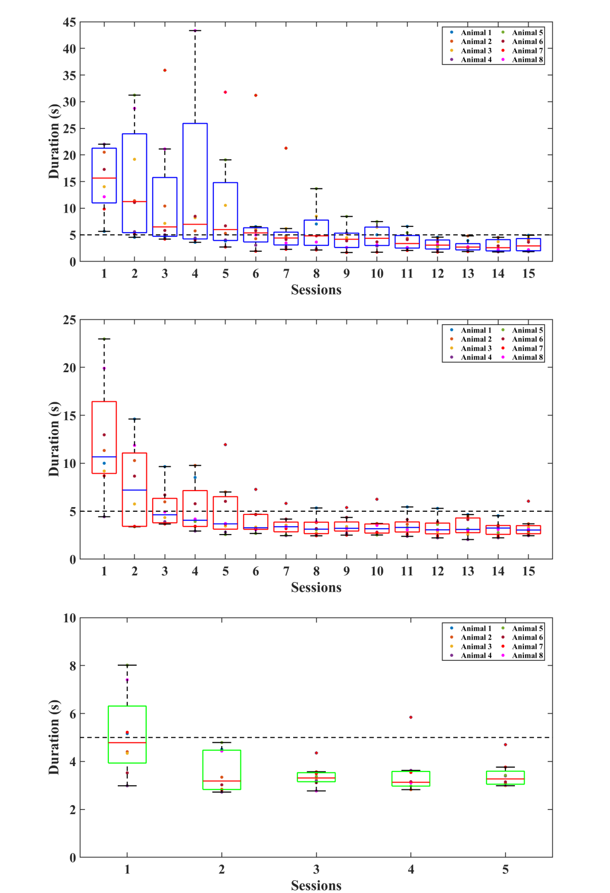

**A**

**B**

**C**

**Fig. S10. Time (in s) taken by the animals to travel from one spout to another spout in the foraging setup**

**58**

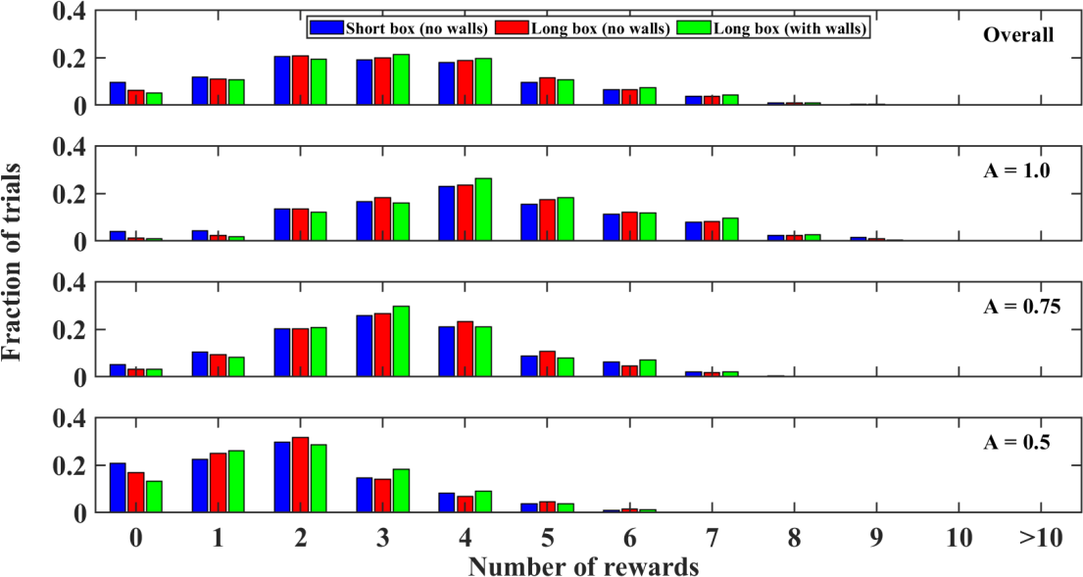

**A.2. TRIAL-WISE ANALYSIS**

The figures of the parameters analyzed in a trial-wise manner represent the proportion or fraction of trials of the performing state sessions constituting a particular value for that parameter. In each figure, the top plot represents the overall fraction of trials for each foraging setup (see the legends for the color codes of each setup). Similarly, the below three plots are representing three different

starting reward probabilities of A = 1.0, A = 0.75, and A = 0.5 respectively.

**Fig. S11. Total number of rewards (food pellets) obtained by the animals in each trial.** The value of zero in the x-axis of this plot represents the trials that were not rewarded during the foraging sessions.

**59**

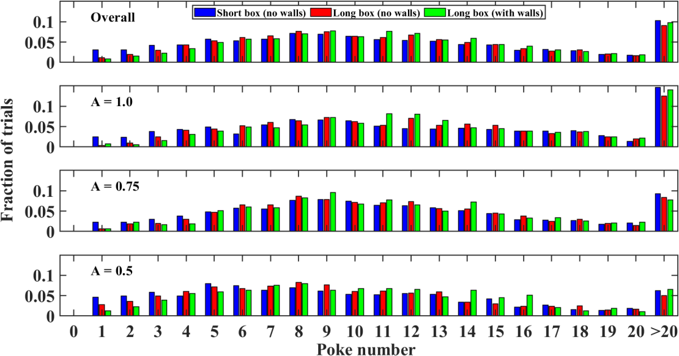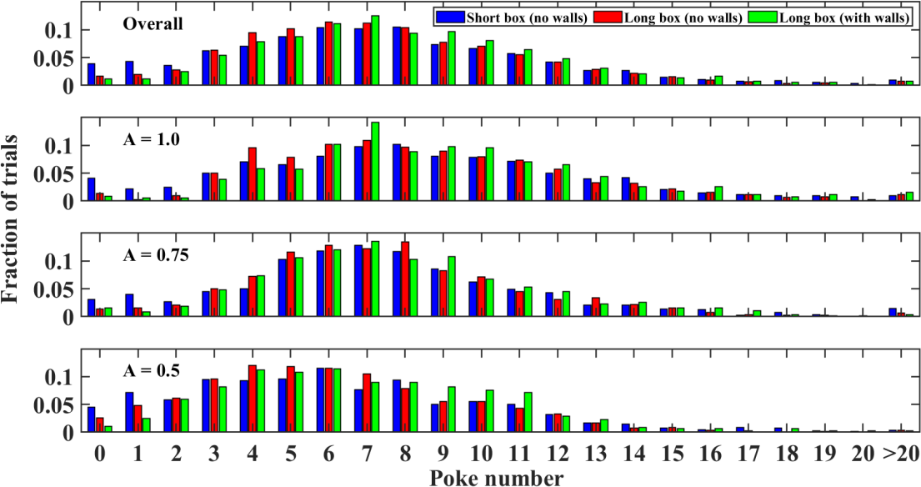

**(a)**

**(b)**

**Fig. S12. Number of nose-pokes done by the animals in each trial.** (a) Total number of nose- pokes consisting of both hit and error pokes; (b) Hit pokes

**60**

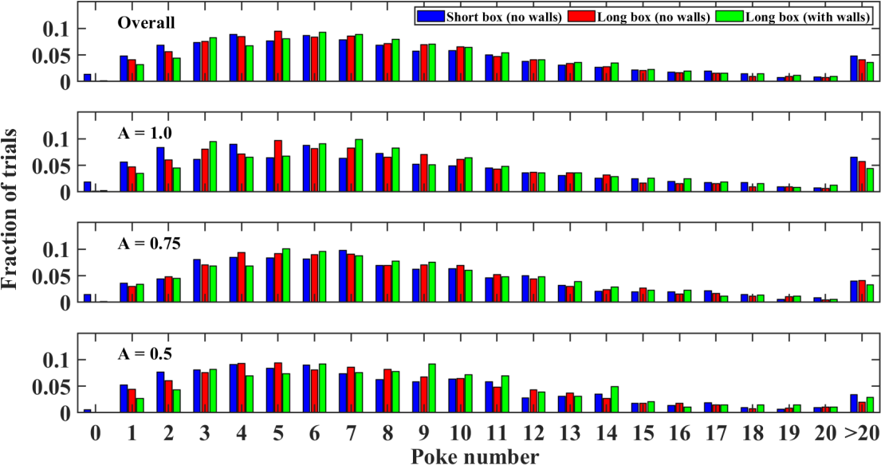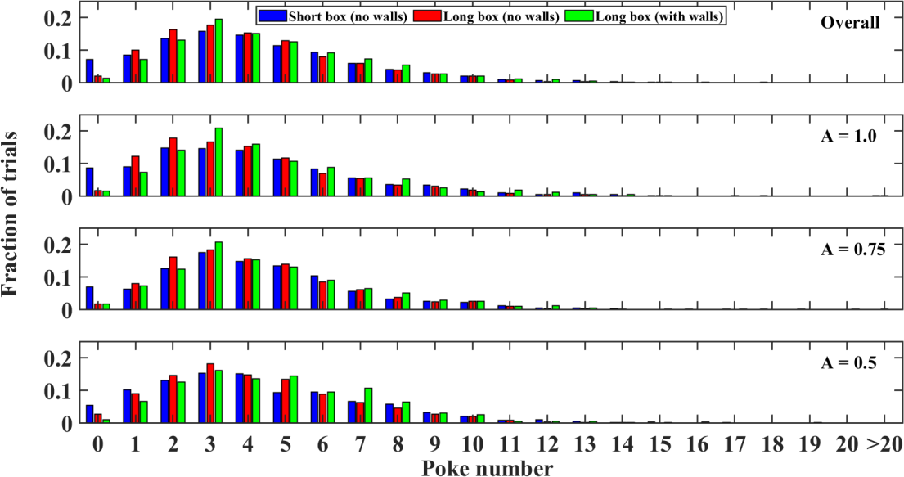

**(a)**

**(b)**

**Fig. S13. Number of unrewarded nose-pokes done by the animals in each trial**. (a) Total number of unrewarded nose-pokes consisting of both hit and error pokes; (b) Unrewarded hit pokes

**61**

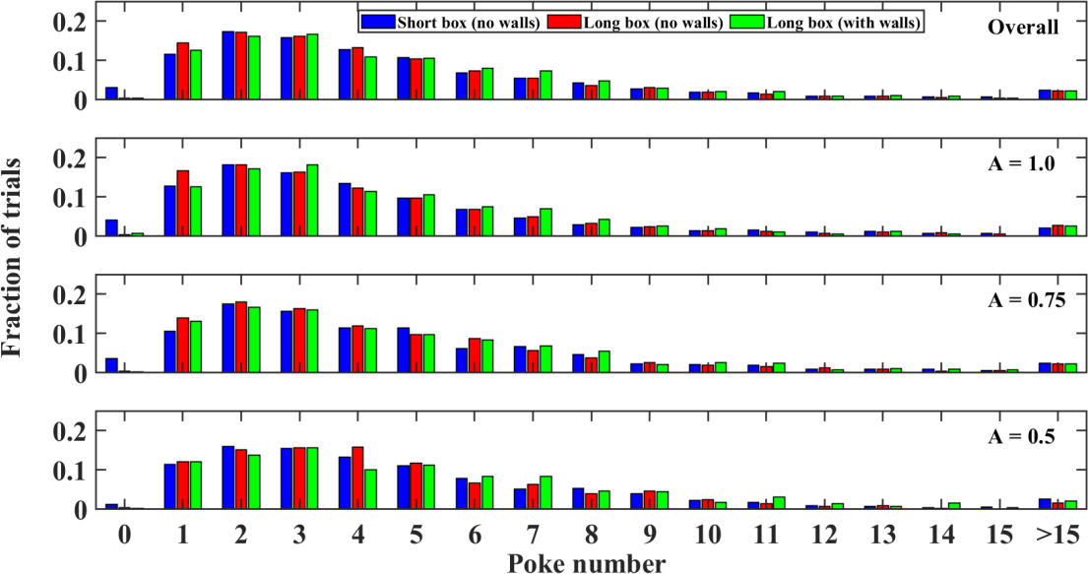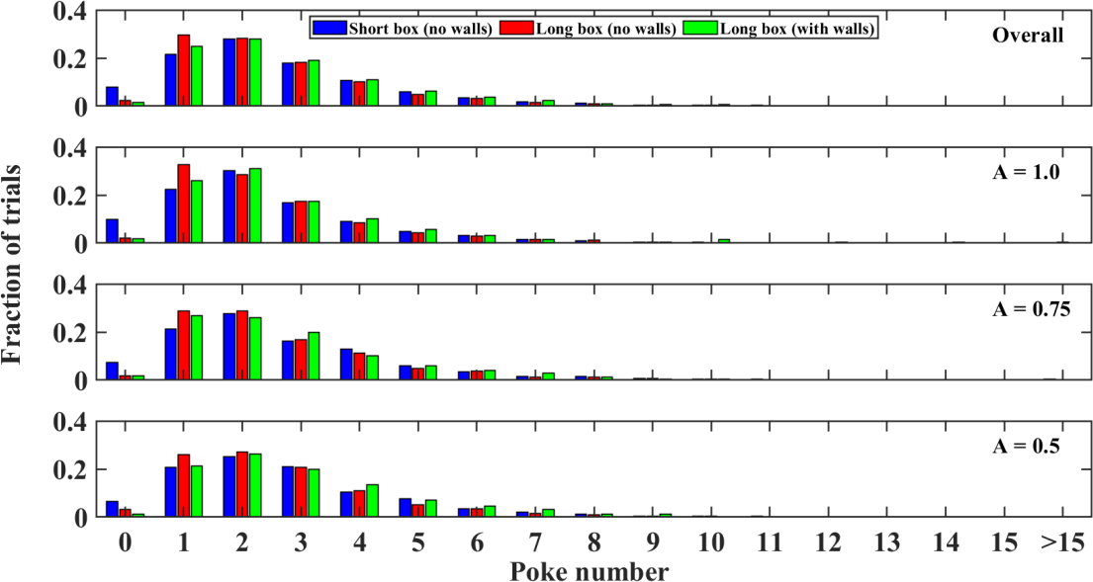

**(a)**

**(b)**

**Fig.**

**S14. Number of consecutive unrewarded nose-pokes done by the animals before**

**leaving the spout in each trial**. (a) Consecutive unrewarded nose-pokes consisting of both hit and error pokes; (b) Consecutive unrewarded hit pokes

**62**

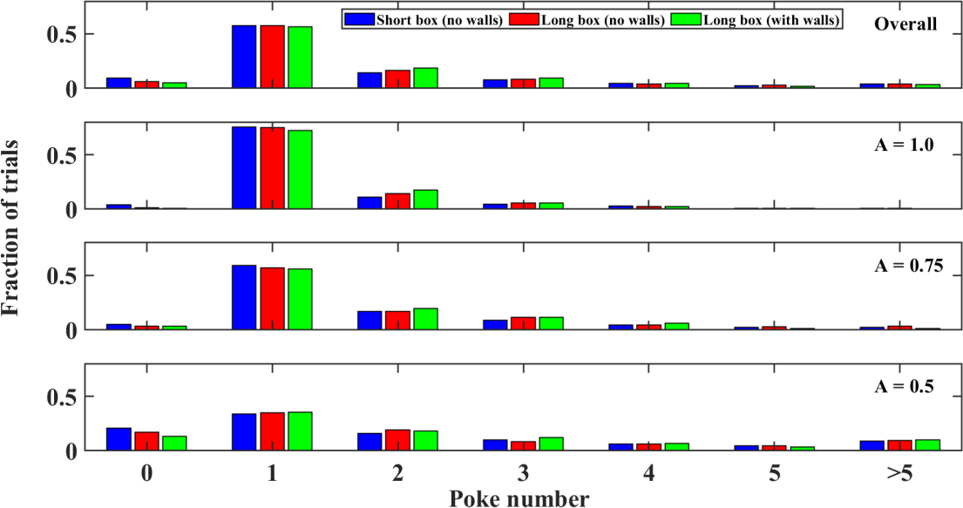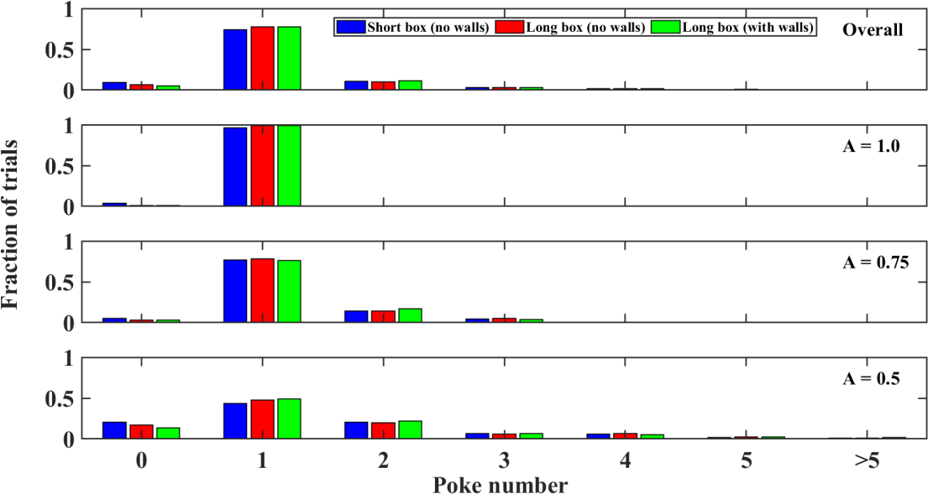

**(a)**

**(b)**

**Fig. S15. Poke number of first reward in each trial**. (a) Poke number consisting of both hit and error pokes; (b) Hit poke number

**63**



**B. SUPPLEMENTARY TABLE**

**Table S16. Total number of trials in different trial types (starting probabilities) in performing phase sessions of different foraging setups**

**C. VIDEO RECORDINGS OF FORAGING EXPERIMENTS**

Scan the following QR code

experiments in different setups.

to

view the

video

recordings

of

the

foraging

**64**

**Setup/Trial type**

**Overall**

**A = 1.0**

**A = 0.75**

**A = 0.5**

**Short box without walls**

3100

1126

1038

936

**Long box without walls**

4432

1737

1427

1268

**Long box with walls**

1760

686

583

491

**7. BIBLIOGRAPHY**

Alonso, R., Brocas, I., & Carrillo, J. D. (2013). Resource allocation in the brain.

*Review of Economic Studies*, *81*(2), 501–534. https://doi.org/10.1093/restud/rdt043

Beharelle, A. R., Polanía, R., Hare, T. A., & Ruff, C. C. (2015). Transcranial stimulation over frontopolar cortex elucidates the choice attributes and neural mechanisms used to resolve exploration–exploitation trade-offs. *Journal of Neuroscience*, *35*(43), 14544–14556.

https://doi.org/10.1523/JNEUROSCI.2322-15.2015

Brunk, M. G. K., Deane, K. E., Kisse, M., Deliano, M., Vieweg, S., Ohl, F. W., Lippert, M. T., & Happel, M. F. K. (2019). Optogenetic stimulation of the VTA modulates a frequency-specific gain of thalamocortical inputs in infragranular layers of the auditory cortex. *Scientific Reports*, *9*(1), 1–15.

https://doi.org/10.1038/s41598-019-56926-6

Charnov, E. L. (1976). Optimal foraging, the marginal value theorem. *Theoretical Population Biology*, *9*(2), 129–136. https://doi.org/10.1016/0040-

5809(76)90040-X

Cheal, M. Lou. (1986). The gerbil: A unique model for research on aging.

*Experimental Aging Research*, *12*(1), 3–21. https://doi.org/10.1080/03610738608259430

Constantino, S. M., & Daw, N. D. (2015). Learning the opportunity cost of time in

a patch-foraging task. *Cognitive, Affective and Behavioral Neuroscience*, *15*(4), 837–853. https://doi.org/10.3758/s13415-015-0350-y

**65**

Daw, N. D., O‘Doherty, J. P., Dayan, P., Seymour, B., & Dolan, R. J. (2006).

Cortical substrates for exploratory decisions in humans. *Nature*, *441*(7095), 876–879. https://doi.org/10.1038/nature04766

Dezza, I. C., Yu, A. J., Cleeremans, A., & Alexander, W. (2017). Learning the value of information and reward over time when solving exploration- exploitation problems. *Scientific Reports*, *7*(1), 16919.

https://doi.org/10.1038/s41598-017-17237-w

Drugowitsch, J., Mendonça, A. G., Mainen, Z. F., & Pouget, A. (2019). Learning optimal decisions with confidence. *Proceedings of the National Academy of Sciences of the United States of America*, *116*(49), 24872–24880.

https://doi.org/10.1073/pnas.1906787116

Fantino, E., & Abarca, N. (1985). Choice, optimal foraging, and the delay- reduction hypothesis. *Behavioral and Brain Sciences*, *8*(2), 315–330.

https://doi.org/10.1017/S0140525X00020847

Karlsson M P ; Tervo D G R; Karpova A Y. (2012). *Network Resets in Medial Prefrontal Cortex Mark the Onset of Behavioral Uncertainty*. *October*, 135–

140.

Kvitsiani, D., Ranade, S., Hangya, B., Taniguchi, H., Huang, J. Z., & Kepecs, A. (2013). Distinct behavioural and network correlates of two interneuron types in prefrontal cortex. *Nature*, *498*(7454), 363–366.

https://doi.org/10.1038/nature12176

Lottem, E., Banerjee, D., Vertechi, P., Sarra, D., Lohuis, M. O., & Mainen, Z. F.

(2018). Activation of serotonin neurons promotes active persistence in a probabilistic foraging task. *Nature Communications*, *9*(1), 1–12.

**66**

https://doi.org/10.1038/s41467-018-03438-y

Mansouri, F. A., Buckley, M. J., Mahboubi, M., & Tanaka, K. (2015). Behavioral consequences of selective damage to frontal pole and posterior cingulate cortices. *Proceedings of the National Academy of Sciences of the United States*

*of America*, *112*(29), E3940–E3949. https://doi.org/10.1073/pnas.1422629112

Ramnani, N., & Owen, A. M. (2004). Anterior prefrontal cortex: Insights into function from anatomy and neuroimaging. *Nature Reviews Neuroscience*, *5*(3),

184–194. https://doi.org/10.1038/nrn1343

Shuai, L., & Song, Y. L. (2011). Foraging behavior of the midday gerbil (Meriones meridianus): Combined effects of distance and microhabitat. *Behavioural*

*Processes*, *86*(1), 143–148. https://doi.org/10.1016/j.beproc.2010.11.001

Stark, H., Rothe, T., Wagner, T., & Scheich, H. (2004). Learning a new behavioral strategy in the shuttle-box increases prefrontal dopamine. *Neuroscience*,

*126*(1), 21–29. https://doi.org/10.1016/j.neuroscience.2004.02.026

Tolnai, S., Beutelmann, R., & Klump, G. M. (2017). Exploring binaural hearing in gerbils (Meriones unguiculatus) using virtual headphones. *PLOS ONE*, *12*(4),

e0175142. https://doi.org/10.1371/journal.pone.0175142

Vertechi, P., Lottem, E., Sarra, D., Godinho, B., Treves, I., Quendera, T., Oude Lohuis, M. N., & Mainen, Z. F. (2020). Inference-Based Decisions in a Hidden State Foraging Task: Differential Contributions of Prefrontal Cortical Areas. *Neuron*, *106*(1), 166-176.e6.

https://doi.org/10.1016/j.neuron.2020.01.017

Zempeltzi, M. M., Kisse, M., Brunk, M. G. K., Glemser, C., Aksit, S., Deane, K.

E., Maurya, S., Schneider, L., Ohl, F. W., Deliano, M., & Happel, M. F. K.

**67**

(2020). Task rule and choice are reflected by layer-specific processing in rodent auditory cortical microcircuits. *Communications Biology*, *3*(1), 1–12.

https://doi.org/10.1038/s42003-020-1073-3

**68**

**DECLARATION**

I hereby declare that this thesis entitled **“Exploratory attentional resource allocation in a probabilistic foraging paradigm in the Mongolian gerbil”** is my original work, and has not been submitted for an award of a degree in any other

university.

Signature

Date

**69**